Lenten Reflection Two - 2024
Archbishop Anne

Laying Down Words

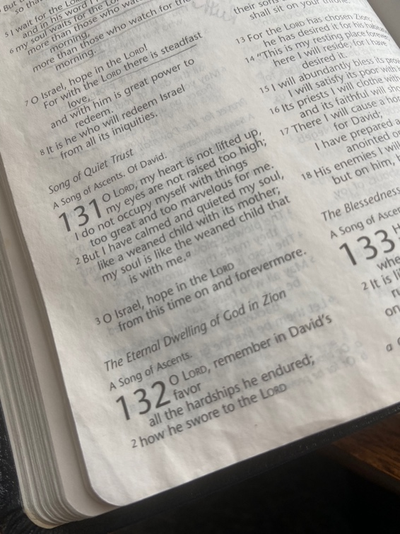

“But I have calmed and quieted my soul.”
Psalm 131. 2

Dear friends in Christ,

“As we prepare for the Paschal Feast, continuing in the apostles’ teaching and fellowship, in the breaking of bread and in the prayers, let us make ready our hearts to renew the covenant of our baptism.” (Gathering Rite - Becoming the Story We Tell - Anglican.ca)

Since Ash Wednesday, we have been encouraged to deepen our prayer lives and communion with God, along with other Lenten practices and disciplines. Many people, including myself, set up elaborate and ambitious lists of all the things they intend to do to make theirs a good and holy Lent including setting aside more time than they normally do for prayer.

But round about this time in the journey, as we enter the fourth week of Lent, the challenges of personal sacrifice become more difficult to follow through. We fall short of our well-intentioned efforts to be faithful in our prayer life or to give sacrificially when we need the money for our own needs.
These failures soon become reminders of how very human we are especially when it comes to the most intimate area of our relationship with God - our prayer life, that ‘thin’ place where heaven and earth meet.

How is your practice of prayer going this Lent? Do you see the value of quiet prayer in a world in which there are many urgent needs and demands on your time? Are you giving enough space to attending your inner life, or do you find you are neglecting this area of your relationship with God? Is there a space in your home where you find it easier to contemplate God? Who or what are you carrying to God in prayer this Lent?

Last week I had the privilege of moderating a webinar with a panel of four women bishops to celebrate the 30th Anniversary of the Consecration of Bishop Victoria Matthews (February 12th in 1994) and the ministry of women in the episcopacy. Each of the bishops was invited to share an opening reflection describing their calling to the office of bishop and their experiences of the episcopate - the joyful and good times as well as the difficult and challenging. Later in the webinar they answered questions posed by the online audience. It was a rich time of listening to these inspiring women telling their stories. Our church is richly blessed by their ongoing leadership.

Not surprisingly, the thing that stood out to me was how prayer is the underpinning of everything these women do. From the intensely private moments of prayer in their discernment to allow their name to stand for bishop, before any big decision is made, at the start of every meeting, to those joy-filled corporate and very public acts of worship prayer is the thread that ties it all together.

“Prayer should be the key of the day and the lock of the night.”
George Herbert: Priest and Poet 1633

Prayer is so vital to everything I undertake and is such a key piece of who I am in Jesus, that when I forego this time with God in the morning in order to get a head start on the day’s work, I know it and it shows. The truth is that I need to pray and want to pray so that God’s guidance underpins all my words and actions. I do not want to ‘gain the whole world and forfeit my soul.’ (Matthew 16.26)

For decades, my day has begun with a cup of tea in hand and a dog by my side in my Quiet Space for Morning Prayer and communion with God. Lately this has been in the Chapel at Bishophurst. My Bible’s cover has been loved off and there are pencil marks underlining key passages of scripture. My prayer books and journals are filled with notes and names marking moments in the lives of those I am praying for and where birthdays and anniversaries of friends and loved ones are remembered.

One section of my journal is devoted to remembering those who have died and another to world/national crises as they occur. Those pages are added to more frequently now. There are the pages devoted to prayers that have been answered and the many prayers of thanksgiving I have to offer.

Over the years, I have looked back at my prayer journals and see the treasure they are for me and how they reveal my spiritual concerns for God to be present in the lives of those I am bringing into the LIGHT.

The time I spend in prayer is the place that gives me life and my life meaning. There I am my most honest self, reminded of what is truly important, of who I am and of who holds me and all of creation. In prayer I know for certain that God holds all of what I am seeing and experiencing now and will in the future.

Our Anglican prayer practices involve the written word and the spoken word. We are blessed with beautiful liturgies for every time of day or night and for every season of the church year. As we gather in community, we pray gathering words of praise, other words confessing our sins. In community we recite the Psalms, sing hymns, affirm our faith in the Creed, proclaim good news in readings, and offer our thanksgivings and intercessions to Almighty God before coming to the altar to receive Jesus in bread and wine. Some have been known to use their petitions to convince God to act in a particular way over a cause that is filled with pain or struggle. I confess that I have bargained with God in one of the most challenging moments of my life.

We assume that praying must be about words because words are so much a part of our world and our relationships with one another. We can hardly imagine a world without them. The early years of a child’s life are spent learning to communicate through words or sign language. We use words to share our thoughts and feelings or describe the experiences that enrich our lives. The hurtful damaging words people have said to us have such a lasting impact that can damage a soul in an instant.

In her book “Tarry Awhile: Drawing on the Riches of Black Spirituality for the Whole Church: The Archbishop of Canterbury’s Lenten Book for 2024,” writer Selina Stone spends much time on the all-important topic of‘ Quiet, helping the readers to embrace it as a means of discovering God afresh - and ourselves, in the midst of it.

Silence is not something we busy humans encourage. The African American mystic, Howard Thurman, claims that it is, ‘not trusted; it is subversive; it must be hidden.’

On the other hand, Selina Stone invites us to give Silence permission to enter our lives as often as we can. As a beginning place, we are invited to read Psalm 131 and reflect on its words. In the midst of the busyness of his life, the Psalmist manages to calm and quieten himself/herself like a child on its mother’s breast.

In the silent presence of God, we discover, as the Psalmist did, that there is a contentment and an ability to rest in the place of abundant love. “A still body and tongue can sometimes enable a still mind and give room for spiritual communion with God. As we focus on the movement of our breath, a gift from God, we are reminded that we are living by the simplicity of our inhale and exhale. In this we remember that we live by God’s grace and mercy…..As we sit still and attend to quiet, we might even have the opportunity to reflect on the urgency of daily movements. In resisting the urge to move and be busy we exercise restraint, a spiritual discipline. We refuse to be conformed to patterns that demand we produce as much as we can.” (Tarry Awhile, page 125 Kindle edition)

While the whole idea of being quiet goes against the grain of absolutely everything I know, the practice of contemplation has renewed my Lenten journey. I am convinced that through the quiet I am better able to gain perspective and see life with a fresh set of eyes. Most especially, it helps me to remember where my help is coming from and where I can really and truly lay down the burdens that have become too heavy to carry alone.

I am rediscovering the mystery and wonder of silent prayer, of ‘laying words down’ and of being known and loved by God beyond the words I most always pray inadequately.

If your Lenten journey through the wilderness is becoming barren, go to the quiet waters and enter into the gift of silent prayer. It will be refreshment for your soul as it is for mine.

With affection and prayer, I remain your ‘trying to be quiet’ bishop,

+Anne

