Entering Holy Week

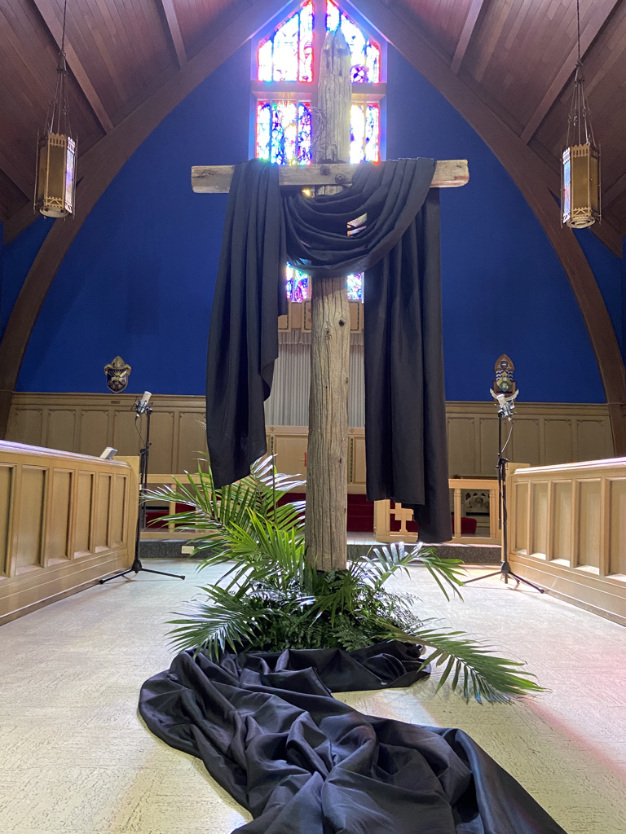

“I simply argue that the Cross should be raised at the centre of the marketplace as well as on the steeple of the church. I am recovering the claim that Jesus was not crucified in a cathedral between two candles; but on a cross between two thieves; on the town’s garbage heap; at a crossroads so cosmopolitan they had to write his title in Hebrew, Latin and Greek……at the place where cynics talk smut, and thieves curse, and the soldiers gamble.
Because that is where he died.
And that is what he died about.
And that is where the church ought to be and what the church ought to be about.”
(George McLeod, Beyond Planning Church, pg. 69)

Dear people of God,

Our Lenten pilgrimage of faith that began on Ash Wednesday now brings us to Holy Week beginning on Sunday March 24th with Palm and Passion Sunday.

A really good Holy Week is one that is made in its entirety - not simply moving from the joy of the parade into Jerusalem on Palm Sunday to the joy of the parade from the empty tomb on Easter Sunday, but by making our way with friends and strangers together in community through the solemn and sacred liturgies of the Triduum - Maundy Thursday, Good Friday, and Holy Saturday culminating in the magnificent celebrations of Easter Day and resurrection joy.

On that day, in a church decked out in all its splendor, we will sing out our hidden ‘Alleluias’ and renew our baptismal covenant as a people of the resurrection who are sent out into the world to live and proclaim the gospel.

This is a week of prayerful listening as we enter fully into each moment of the unfolding drama of Jesus’s passion, death, and resurrection. Sermons will be preached - good ones, I hope, feet will be washed, altars will be stripped, hymns will be sung, the cross will be venerated, and prayers for the whole world will be offered.

The extended gospel may be too much to take in all at once especially the details of an innocent man unjustly condemned by a kangaroo court and then beaten and hung naked on a cross. Mark goes to great lengths to describe the horror, the humiliation, and the mocking Jesus endured in a very public way.

The Passion of Jesus should make us recoil at humanity’s ability to be cruel, then and now. But it should also lead us to consider how we might bring forth a different vision of the world for Christ’s sake. As we follow the passion from trial to crucifixion, remembering people named and unnamed who witnessed it, our most faithful response would be a people who are transformed to the point that we as the body of Christ say ‘never again’ to such unjust killings.

The opportunity and invitation of Holy Week is to take its message of love and live a different kind of life in God’s name, transforming violence and hatred into God’s reign of justice and peace. This kind of life is not only possible – it is a promise that God has made to us.

Difficult though it is, try to stay for the whole week of liturgies and allow the extended gospel readings to settle deep down into your soul and grow something new in you.

The ‘new’ has a name, and it is Jesus.

Jesus, who went freely to the cross for the sake of the whole world he loved so much.

Jesus, Emmanuel, God-with-us in the Incarnation and God-with-us in Holy Week.

In all places where God will be worshipped this week, God is with us, loving us, holding us, forgiving us. Our faith will be formed this week as we join the journey with Jesus in body, mind, and heart, in humility. It will lead us, as it did our Saviour from humiliation to exaltation. This week, like Jesus, we go from down to up.

Following the difficult Covid years of not being able to gather for in person worship, we can freely do so now. Our clergy and lay leaders are working hard to prepare for Holy Week and are looking forward to welcoming you to join them in one of our many churches this week.

Know this, for it is true….

You are welcome there, especially if you haven’t experienced the fullness of Holy Week before.

You are welcome there, if you’ve been away from church for a long time.

You are welcome there, if you’ve never missed a Holy Week in your life.

You are welcome there, just as you are, filled with your fears and failings, disappointments, doubts, and questions and all the joys and dreams and hopes stirring in your hearts.

You are welcome there, to begin afresh, if you are carrying in your heart guilt from past sins or a hurt you are finding difficult to forgive.

You are welcome there, if you are new to faith and are not familiar with Anglican ways.

I will be there too – at Redeemer Thessalon on Palm/Passion Sunday, at St. Luke’s on Thursday morning for the Blessing of Oils, at St. Luke’s for Maundy Thursday and Good Friday, at Emmaus for the Easter Vigil on Holy Saturday, and at St. Luke’s for the Day of Resurrection.

I hope you will be somewhere too, staying with Jesus through it all trusting that Jesus will be with you through it all.

In the epilogue of the book, “Tarry Awhile: The Archbishop of Canterbury’s Lent Book 2024”, Selina Stone closes with these words about that first Easter morning:

“Jesus, the light of the world, is hidden away in the darkness, away from prying eyes and grasping hands. His followers are scattered and weeping, and even those who did not believe realize more clearly after his death who he was. But at some point, after the sealing of the tomb and the last trace of light is gone, darkness proves itself to be the primes space in which the Spirit of God is at work. Within the tomb, the same Spirit of God who hovered over the deep dark once again brings forth life, this time within Jesus’ own body.”

May you know this light and life this Holy Week and Easter,

+Anne

