“Lent, the season of unpleasant uncomfortability.”

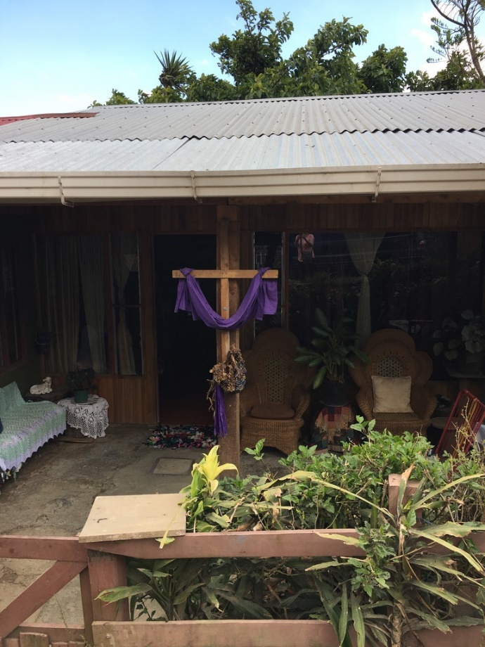
A cross draped in purple outside the home of a Costa Rican family
Photo: Anne Germond March 2017

Dear friends,

Let me begin my first Lenten reflection with a story renowned preacher, William Willimon, tells about the time he was serving as the pastor in a coastal town in South Carolina. About this time of the year there was quite a ruckus in the community. The reason – three large crosses the local Episcopalian/ Anglican church had placed on their lawn adjacent to their church. To add to what would become known as ‘the great offence’ they draped them in purple, for Lent.

It only took a week of them being up for the church to receive a call from the local chamber of commerce.

“This is a big season for tourists,” they said. “We think those crosses could send the wrong signal to visitors at the beach. People don’t want to come down here for vacation and be confronted with unpleasantness.”

The church, Willimon says, stood its ground. The three crosses stayed. “It’s Lent,” said the church. “People are supposed to be uncomfortable.”

Willimon ends the story with these words, “Lent, the season of unpleasant uncomfortability.”^{1.}
I know exactly what he means.

There’s something really awkward about leaving an Ash Wednesday service heading into the real world with a black smudge on your forehead. I went to a store after the morning service last Wednesday when enough time had passed by that I’d almost forgotten it was there. One teller pointed to her own forehead as if to say – there’s something weird happening on your head. Other people just stared. I was surprised about how ashamed and embarrassed those ashes made me feel.

But that whole day was also powerful for me, filled as it was with reminders of the frailty of life, of how everything can disappear in a second, and of how utterly dependent I am on God’s grace, mercy, and forgiveness.

The morning of Ash Wednesday, I officiated at Holy Trinity Church in the Sault which will soon be torn down, reduced to dust and rubble, so that Cara Four, a new housing project, can be built in its place. “It will be like the phoenix rising,” expressed Canon Fran Glover. I know this to be a difficult stressful time for the members of that parish who will be bidding farewell to a much-loved building – every inch of it filled with memories. We’re told that when the bulldozer comes the little white church on the hill will be obliterated from Great Northern Ave in three days. Everything we cherish in this life including our own bodies ends up this way – dust and ashes.

It wasn’t just the ash smudge in the shape of a cross that I wore all day that made Ash Wednesday so powerful for me – perhaps for you too. It was also the somber recitation of the 51st Psalm with its contrasting images of sinfulness and mercy.

“I know my transgressions and my sin is ever before me,” in the first part of the Psalm is replaced with words of re-creation and restoration – “Create in me a clean heart, O God; Cast me not away from your presence; Give me the joy of your saving help….and my mouth shall proclaim your praise.”

Then there was the powerful Litany of Penitence in which the whole community kneels together as it confesses to God the truth about our lives. Ten reminders of how we have failed God and failed one another. To help us face the pain of our own transgressions. “Have mercy on us, Lord. Accept our repentance, Lord. Hear us, Lord for your mercy is great.” Check them out on page 284 in the BAS and you will see what I mean.

Yet, the more I thought about it and think about it still, I experienced such a sense of hopefulness and honesty on Ash Wednesday and do now this first week of Lent. The truth about this season of unpleasant uncomfortability is that God can change us. That God wants to change us.

And that is hopeful good news.

In contrast to William Willimon’s experience as the pastor of a church in South Carolina, when Colin and I were tourists in Costa Rica at the beginning of Lent in 2017, we noticed crosses draped in purple cloth were as common on the front lawns of houses as inflatable Santas in Canada before Christmas. There was no shame in it; no apologising for the fact that, as Christians, they are in a season of penitence.

We should be doing the same. Taking the apology out of Lent. If we take the time in these 40 days seriously, there can be something really invigorating about Lent. The word “Lent” comes from an Old English word that means ‘spring season’. Lent is a time for spiritual spring cleaning.

These forty days are among the most counter cultural and subversive in the Church year. Renewed focus on honesty about temptation, confession of sin, the inner desire to deepen our prayer lives, to fasting as a way to heighten our awareness of the many injustices in our world - these things no longer come naturally to us in the death defying, power seeking, success driven, feel -good- about- ourselves culture that we live in.

Barbara Brown Taylor reminds us that Christians are called to, “Understand God’s grace as something more than the infinite remission of our sins. If we want to take part in the divine work of redemption, then we will also understand God’s grace as the gift of regeneration….complete with new vision, new values, new behaviour.”^{2.}

I love Pope Francis’s bold comment to, “Eat whatever you want. The sacrifice is not the stomach but in the heart.” Lent moves us forward inch by inch in this direction of all things new. Indeed, at our Easter Vigil celebration we will be renewing our baptismal promises and recommitting to live as the people of the resurrection that we are, living in a covenantal relationship with God.

On the First Sunday in Lent we listened to a passage from Genesis about God’s desire is to be in a covenantal relationship with us.

God said: “This is the sign of the covenant between me and you and every living creature. I have set my bow in the clouds and it shall be a sign of the covenant. When the bow is seen in the clouds I will remember my covenant.” (Gen.9.12; 15)

In the light of that bow, the rainbow, humanity can see God as “One who Remembers” even in the midst of the chaos of our lives and our world. God is the One who desires redemption, restoration, healing, wholeness, and forgiveness for us corporately and individually.

How do you experience God as the “One who remembers you?”

We all know chaos and destruction resulting in ashes as it comes into our lives through relationships broken by illness or death, estrangement or divorce, illnesses of body, mind, or spirit, through addictions of all kinds. To see and know God as the One who remembers us with love and forgiveness in the midst of life’s chaos with all its pain and suffering, is to discover redemption.

I was at Christ Church on the west end of the Sault a few Sundays ago. And there was a hand painted rainbow bending over Noah’s ark with its doors wide open and spilling out into the new world pairs of animals into a new world. We offer this story as a central message of God’s love and hope to our children at the earliest of ages. Isn’t it telling that we want them to know that even in the midst of the worst chaos, God will never forget them?

I pray that God’s children hearing the story that “God is the One who remembers,” in war torn Ukraine and Gaza, in refugee camps in South Sudan or in our own parishes will hear the message of the outpouring love of God loud and clear in this moment.

But what if this Lent, we take that message of covenant and promise, of hope and renewal and, remembering that God remembers us out of the nurseries of our lives, bring it into our worship, our committee meetings, our children’s and youth ministry programs, our outreach, our Bible or book studies, our choir practices, and our fellowship. How wonderful would that be? How different would our worship and meetings and every other thing in our churches be if patience, forgiveness, compassion, and care spilled forth from us.

What an extraordinary promise for the body of Christ. If it is taken intentionally, it could profoundly change a faith community. Not into a place of false perfection but into a place where people are willing to be remade in the image of God’s heart. A place where we could let our hearts be broken open with grief over our hardness of heart and our inability to do anything about the chaos in our world. So that with our hearts broken open we can partner with the Creator through patient, loving, prophetic action to do our part to renew the face of the earth.

This journey through Lent can be a long journey of ‘unpleasant uncomfortability’ if made honestly and openly. Like Jesus’s time in the wilderness, Lent may be a time of significant testing as we confront the beasts within.

Our Lenten journey will pass through the passion and the Good Friday cross all draped in purple, but it will end up on the other side of the resurrection. I say it is a journey worth taking. Let us continue on this journey in our own contexts, within our faith communities trusting that God’s Spirit will be with us and that as they did for Jesus, the angels will wait on us.

I remain yours in the hope of Christ,

+Anne

References:

- William Willimon’s Lectionary Resource, 2017 by Abingdon Press.
- Taylor, Barbara Brown. Speaking of Sin: the lost language of salvation. 2000. Cowley Publications. Rowman and Littlefield Publishers inc.

