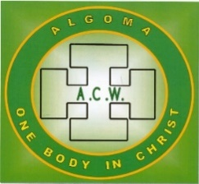
ACW ANNUAL DIOCESAN REGISTRATION –
May 28th, 29th, 30th 2024

Name _____________________________________ REGISTRAR
JACQUIE HOWELL
Address ______________________________ 401-35 DAIRY LANE
HUNTSVILLE P1H 2L8
City _______________________ Postal code ___________

Telephone ____________________

Email ______________________ Deanery _________________

ALL REGISTERED DELEGATES ARE VOTING DELEGATES - MAXIMUM OF 4 PER CHURCH

REGISTRATION Form and PAYMENT DUE BY MAY 1, 2024

Full package: __________ $115.0 Includes all sessions, 2 lunches, coffee breaks
and banquet

ONE day package ________ $ 35.00 Includes daily session, coffee breaks and lunch

Indicate Day: Wednesday _____________ or Thursday _____

Banquet only __________ $55.00 Late Registration (after May 6) $10.00 ______

Dietary restrictions.. __________________________________________________________________

REGISTRATION FORM and FEE TO BE RETURNED TO JACQUIE HOWELL
NO LATER THAN MAY 6, 2023

Cheques payable to the Diocese of Algoma
Or E transfer acwjacquie@gmail.com with Registration form to be sent via email
No refunds after May 6
_____
ACCOMMODATION Check Information Sheet for details
You must make your own reservations directly with hotel. 1 705 - 990-4661
NO LATER THAN APRIL 30TH

HOME2 Suites by Hilton INCLUDES Breakfast WIFI & parking
Plus taxes, (13% HST 4% MAT)

