The Most Reverend Anne Germond
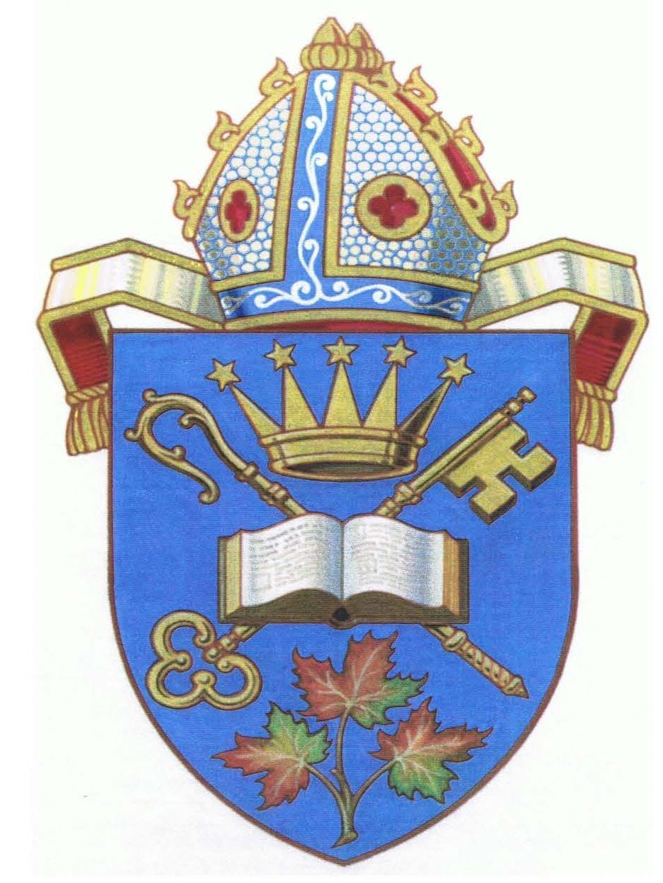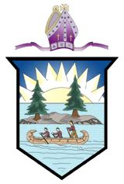
DIOCESE OF ALGOMA DIOCESE OF MOOSONEE
619 Wellington Street East 331 5th Avenue
Sault Ste. Marie, ON P6A 2M6 Timmins, ON P4N 5L6

Monday October 16th, 2023

Dear people of God,
The sea of violence in Israel and Gaza continues to escalate with innocent civilians caught in the midst of this political and military crisis. Already living in fear and uncertainty the events of the last week have only exacerbated their suffering and desperation.
Thousands of innocent people have already died and families anxiously wait for news of those who are missing. The images we see in news casts are horrendous to our eyes. Imagine the horror of children and young people, of the frail elderly, of ordinary citizens who are experiencing that devastation and turmoil every moment of their lives.
Our Primate Linda Nicholls and the Evangelical Lutheran Church in Canada National Bishop have issued a Statement on the situation in the Middle East which can be found here. https://www.anglicanlutheran.ca/wp-content/uploads/Statement-on-War-in-the-Holy-Land.pdf
In his pastoral letter from the City of the Resurrection, Anglican Archbishop in Jerusalem and the Primate of the Province of Jerusalem and the Middle East, Hosam E. Naoum, has sent out a call to all congregations, institutions, and parishioner families to observe Tuesday October 17th, 2023 as a day of fasting and prayer for peace in the Land of the Holy One.
As we accept this invitation let our prayers be for justice, reconciliation, peace, and an end to hatred and violence, for God, “Is not the God of disorder but of peace.” (1 Cor. 14.33)
Let our prayers be for God to work in the hearts of decision makers, peace makers, and those who are working at ground level to bring humanitarian aid to those whose lives are on the very brink of collapsing. In this time of anguish, let our prayers also be for hope so that death’s sting is not the only word that is heard.

-2-

Please organize a group of parishioners to pray with on Tuesday - either in person or online. There is a noon Eucharist at St. Luke’s Cathedral to which those in Sault Ste. Marie are invited. On Wednesday evening (18th October) at 7pm we will mark the Feast of St. Luke with Eucharist in the Bishophurst Chapel and offer prayers for peace. There will also be an opportunity for those in attendance to be anointed with healing oil.
The Archbishop of Canterbury has written the prayer below for our daily use. I commend it for your personal and public prayer.
May the Healer of the Nations and the One who knows and shares the suffering of the world pour upon our spirits the balm of Gilead and anoint us today and always,

+Anne
Archbishop of Algoma and Moosonee

God of compassion and justice,
We cry out to you for all who suffer
in the Holy Land today
For your precious children, Israelis
and Palestinians,
Traumatised and in fear for their lives;
Lord, have mercy.
For the families of the bereaved,
For those who have seen images they will never forget
For those an anxiously waiting for news,
despairing with each passing day;
Lord, have mercy.

For young men and women,
heading into combat,
bearing the burden of what others
have done and what they will be
asked to do;
Lord, have mercy.
For civilians in Israel, Gaza and the
West Bank, that they would be
protected, and that every life would
count, and be cherished and
remembered;
Lord, have mercy.
-3-

For the wounded, and those facing
a lifetime of scars
for those desperately seeking
medical treatment where there
is none:
Lord. have mercy.
For medical and emergency
personnel, risking their own lives
to save those of others;
Lord. have mercy.

For those who cannot see anything
but rage and violence,
that you would surprise them with
mercy, and turn their hearts towards
kindness for their fellow human beings;
Lord, have mercy.
For people of peace
whose imagination is large enough
to conceive of a different way
that they may speak, and act,
and be heard;
Lord, have mercy.

Mighty and caring God,
you promised that one day
swords will be beaten into
ploughshares, meet us in our
distress, and bring peace upon
this troubled land.
Amen

