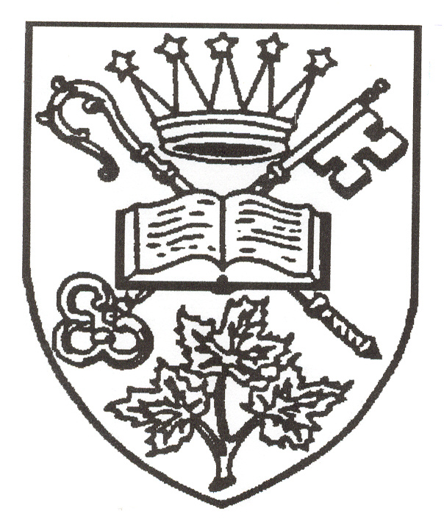
The Diocese of Algoma

Synod 2023
Elections:

General Synod – 2 Clergy/2 Lay/1 Youth
The next session of the General (national) Synod will meet in 2025. Our Synod elects delegates and substitute delegates from among its members. Delegates may ask to be appointed to General Synod committees, or for election to the Council of the General Synod but this is not required of our delegates. Delegates serve a three-year term from Synod to Synod.

One Youth Delegate and one alternate Youth Delegate are elected to represent Algoma at General Synod. The Youth Delegate must be over the age of 16 and under the age of 26 AT THE TIME OF GENERAL SYNOD.

Provincial Synod – 4 Clergy/4 Lay/1 Youth
The next session of the Provincial Synod will meet in Sault Ste. Marie in the fall of 2024. Our Synod elects delegates and substitute delegates from among its members. One of our lay and one of our clergy delegates to the Provincial Synod will be chosen by our Provincial Synod delegates to join our Bishop in sitting as members of the Provincial Council. Delegates serve a three- year term from Synod to Synod.

One Youth Delegate and one alternate Youth Delegate are elected to represent Algoma at Provincial Synod. The Youth Delegate must be over the age of 16 and under the age of 26 AT THE TIME OF PROVINCIAL SYNOD.

Diocesan Court
The Diocesan Court has been established to hear and determine all causes referred to it by the Bishop or Executive Committee for offenses against the provisions of the Constitution or Canons, the Provincial Synod of Ontario, or of the General Synod. The Diocesan Court shall hear and determine all other causes or questions referred to it by the Bishop or the Executive Committee.
The President of the Court is appointed by the Bishop and is a non-voting member. Our Synod elects one clerical and two lay members who then choose two other members to achieve a composition for the Court which is balanced in terms of gender, age, lay and clerical.
It is not anticipated that the Court will meet over the next two years, but its members must be in place in case this should prove necessary.

Primate’s World Relief and Development Fund Representative
Our Synod elects a representative who acts as liaison for the PWRDF within the diocese. There is an annual meeting in Toronto in the Fall.

Bishophurst Maintenance Committee
Our Synod elects two Members of the Bishophurst Maintenance Committee, along with two alternates. The Committee provides advice and assistance on the maintenance of Bishophurst, the Bishop’s residence in Sault Ste. Marie. Those elected do not need to be members of our Synod but, should be resident in Sault Ste. Marie.

Diocesan Executive Committee
The Diocesan Executive Committee meets three times a year from Synod year to Synod year. Currently, two meetings are held via the zoom platform and one in-person meeting is held in Sudbury in November, mid-week for a day and a half. The Synod elects one Youth Delegate to represent them on the Executive Committee from nominations received from the youth.

THOSE WHO WISH TO STAND FOR ELECTION TO THESE OFFICES ARE INVITED TO COMPLETE THE FORM ATTACHED.

The following example is given as a sample of what such a completed form could look like.

Name
Joan M. Smith

Office
Youth Member of the Executive Committee

Biographical Information (maximum of 50 words)
A longtime member of St. Cuthbert’s in Espanola who has served as a Youth Synod delegate for two years; a Diocesan Synod delegate this year; a member of the Youth Ministry Committee for three years. I have also worked on developing youth ministry within my parish.

Reasons for standing for Election (maximum of 100 words)
I am particularly interested in the increased involvement of youth within the Anglican Church locally and at the Diocesan level and feel I can make an important contribution representing our youth at the Executive Committee table. I am a first year university student residing within the Diocese of Algoma where I intend on finishing my four year program and, therefore, would be in touch with the issues/concerns being experienced within the Diocese of Algoma.

CANDIDATE INFORMATION FORM FOR ELECTIONS AT THE 2023 SYNOD

This form is provided for your convenience and the information does not need to be submitted on it. Candidates are at liberty to use any format they like, but it must include only the following information, be on a single sheet of paper, and not exceed the maximum word limit.

Name

Office

Biographical Information (maximum of 50 words)

Reasons for standing for Election (maximum of 100 words)

