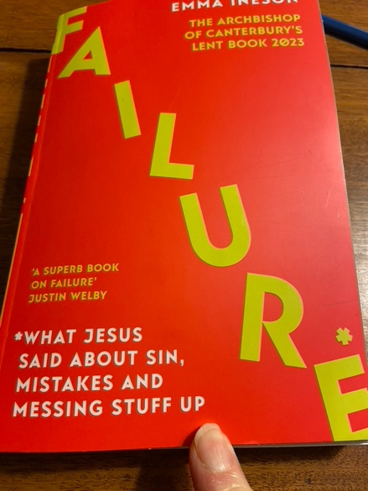

**Lent and Eastertide Book Study**

***“Failure”***

**by Bishop Emma Ineson**

Dear friends in Christ,

You are invited to join this year’s Lenten book study which I will be leading online.

“Failure” is the Archbishop of Canterbury’s Lent 2023 book and is

authored by Bishop Emma Ineson who serves as the Diocese of London’s Bishop of Kensington. It is available on the Kindle format and from Amazon.ca at a cost of $16.

In the foreword to “Failure” the Archbishop of Canterbury Justin Welby writes this about the book, “*This is a very good book, rooted in Scripture: it will disturb us when we are too comfortable, and comfort us when we are too disturbed. It calls us to let God be the judge, and calls us to take comfort in his merciful and hope-filled judgement.”*

I have just finished reading it and it left me feeling hopeful not helpless, and not a failure at all.

There will be one introductory evening session during Lent (March 9th 7pm to 9pm) and one evening session during Eastertide (Wednesday April 12th 7pm to 9pm). This will allow participants the opportunity to read the book during Lent and participate fully in the discussion during Eastertide.

Everyone is welcome. Please register by emailing Liz Hamel at [liz.hamel@dioceseofalgoma](mailto:liz.hamel@dioceseofalgoma).com so that she can send you the Zoom link for both online sessions.

Looking forward to welcoming you into our book study group,

***+Anne***