December 9, 2022

Dear friends in Algoma and Moosonee,

My siblings, Paul, and Helen, and I would like to thank you for the many messages of condolence that we have received from you over the last two weeks, since our mother Nora died. People of faith know how to reach out and care for one another in their time of grief, and our family have been the recipients of your compassion.

The prayers you have offered personally or during your worship services have sustained us through this very trying time. We especially appreciate the online diocesan prayer service organized by Archbishop Fred on the eve of mom’s funeral which gave some of our family members, not able to travel to Johannesburg, the opportunity to participate in a prayer service.

Mom has been in failing health since the first Covid lockdown in March 2020. Our family was fortunate to be able to provide her with carers who lived in her home in the Retirement Village where she lived and who gave her the best of care 24/7. Physically she improved but mentally she declined, especially as she said goodbye to one friend after another. She took each loss hard and withdrew more and more into herself.

In November, I made the decision to travel to South Africa ahead of my planned vacation in December to spend time with mom, and to support my brother Paul and sister-in-law Tracy who have been the most wonderful son and daughter-in-law a mother could ever wish for, helping her cope with daily life as she became less and less independent.

I think mom recognized me when I arrived but a week into my visit, she took a turn for the worse and died within a few days. Our family was supported by an entirely mobile palliative care medical practice who visited us at home and taught us how to care for the dying. Our darling mother died peacefully in her own bed surrounded by the prayers of her family and the church on November 23rd. My brother Paul and I were with her when she died and found it to be a sacred moment and a holy relief that she was out of her pain and finally at rest.

A woman of enormous faith mom’s final words to us were a prayer, asking God to love us and protect us. As she prayed them, I was reminded of Jesus’s farewell discourse to his disciples the night before he died.

Mom’s funeral was held last Friday (December 2nd) at the Catholic Church where we all grew up in the faith. When Paul and I visited the priest ahead of the service, floods of memories of time spent in that local parish church came back to us. We were formed in our faith at home, at our mother’s knee. She taught us to pray, about the importance of giving generously of our time and talent, of joyfully serving the church and the community, and of loving the faith community we were a part of even if we didn’t like them or necessarily agree with them!

One of mom’s BIG things was never to be late for church. Alas, on the way to the church on her funeral day, the hearse carrying mom’s coffin got a flat tire. Mom arrived at her own funeral half an hour late! My brother and his friends played praise music on their guitars and sang all of mom’s favourite hymns while we waited for the Requiem Mass to begin.

Mom’s funeral was a wonderful service of thanksgiving for a long life, well lived. We expected about 40 people and there were close to 100 people present. Afterwards the faithful women of the CWL (our ACW) provided a wonderful lunch for everyone present. It turned into a time of sharing memories where we learned of mom’s generosity over the years. One of her friends spoke about the year their family received their very first Christmas gifts…from our mother. Something she never told us about. Later we learned that she and dad had purchased the land for this family to build their present home on.

Mom’s ashes will be interred in the Garden of Remembrance at St. Martin De Porres Catholic Church tomorrow morning. I’m so pleased Colin is here and will join me for this private service.

I am keenly aware that many of you have said farewell to beloved parents over the last few years. It’s never easy even though death is a natural part of life. As you have prayed for me, know that as we draw closer to Christmas through the season of Advent, that for those of you who find this time of the year difficult, that you will be in my prayers also.

May the God of hope be with you and bring you comfort and peace.

In Christ’s joy as we continue our Advent journey,

*+Anne*

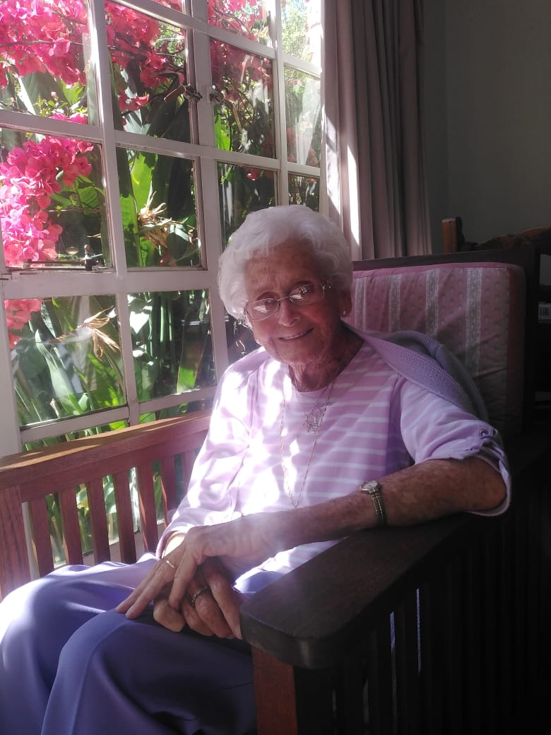

*Mom one year ago*

***“Her children rise up and call her happy:***

**‘Many women have done excellently,but you surpass them all.’*”***

***Proverbs 31.***

Archbishop Anne’s eulogy for her mother, Nora Derbyshire

December 2nd 2022 at St. Martin De Porres Catholic Church, Johannesburg, South Africa.

On the Lambton Quay in Wellington New Zealand stands a three metre tall elegant statue called *Woman of Words*. It was commissioned by the city to celebrate the life and work of one of New Zealand’s famed writers, Katherine Mansfield with the stainless steel work entirely cut with quotations from the author.

During the day the sculpture reflects the colour, movement and ambience of the surrounding area, and when it is illuminated at night from within, the work becomes a lantern of silhouetted words.

Mom, Nora, Nor Nor, Granny was a *Woman of Words*.

Like that lantern of silhouetted words on the quay, when spoken our mother’s words had the ability to light up a room, a life.

Today, we in our own faulty words have tried to capture something of mom’s life and of how she enriched our lives and the lives of so many people through her love and care of them. We know they are inadequate in capturing everything about mom, but we believe that her spirit of joy and kindness lives on in all of us when we speak like her, act like her, and model the kind of life she lived through her faith in Jesus Christ.

Whether our relationship with mum was as a child, or grandchild, a friend or neighbour, a carer, or a co worker in Christ’s service, each one of us has been -

Enriched by her words of encouragement and congratulations in her poetry and prose when there was something, anything to celebrate,

Uplifted by her words of prayer when there was something to intercede for,

Comforted by her words of consolation when there was something to weep over,

Delighted by her granny kind of boasting when one of her children or grandchildren’s accomplishments could not be held within her own family circle,

Felt welcomed by her words of welcome and hospitality,

Affirmed by her words of gratitude when there was something to be thankful for,

Made glad by her words of joy in faith when a prayer was answered,

Consoled by her words of sorrowful acceptance when it was not,

and enlivened by her words on all other occasions and on ordinary days times when she simply wanted to check in and share news from near of afar.

Our mother’s words came in every form spoken, written, and through her eyes and smile, I could not recall an unkind word spoken by her until she shouted at me for hurting her last week, and reminded me that she did not have her hearing aid in and couldn’t hear a word I was saying!

In the last week as we have been sorting through mom’s many possessions we came across books and books of mom’s words written over many years in her diaries and her poetry which were marvellous to find. Interestingly, they are some of the only things we will be keeping, having given everything else away, as per mom’s request.

One of the most difficult things for all of us over the last year or so is that bit by bit as her memory loss became more and more pronounced mom began to lose her words, her ability to engage or have an easy conversation with family or friends.

But in her life, the words mom spoke and wrote and expressed came from the deeply held convictions of her faith- words that she herself had heard and prayed and lived into as a beloved child of God throughout her life.

They came from the written Word of God, the spoken Word of God, the Living Word of God, her Lord and Saviour Jesus Christ. So, it was no surprise to any of us when she was dying that when we prayed the Lord’s Prayer with her, or the Hail Mary or the 23rd Psalm that those sacred words fell easily from her lips illuminating the darkness of the room and the solemnity of the moment.

Helen, Paul, and I would like to thank the people who remained close to mom over the last years; who brought words of hope and encouragement to her each day; who sang with her; laughed with her; were patient and kind with her; and who loved her not for who she had become in her old age, but for who she was at the very core of her being.

Scott Fitzgerald once said this, and it is so appropriate for our mother: “She was beautiful, but not like those girls in the magazines. She was beautiful for the way she thought. She was beautiful for the sparkle in her eyes when she talked about something she loved. She was beautiful for her ability to make other people smile, even if she was sad. No, she wasn’t beautiful for something as temporary as her looks. She was beautiful deep down to her soul. (F Scott Fitzgerald)

And so I end these words with mom’s words, some of the last words she ever spoke. They were in the form of a prayer and I offer it as mom would offer it, with a heart full to overflowing and a life of gratitude.

*“Dear Lord, I thank you for all the gifts I have received in the past. I thank you for your Love, I thank you that you will always be there, that you are always there. I love you. I thank you that you are with those I love. Protect them from all harm. Keep them safe. Watch over them and love them as you have never loved them before. I thank you for your kindness, generosity, your goodness, and your presence in my life. Thank you, Jesus, for your preciousness. Thank you for your generosity and your kindness. I love you and I thank you and I praise you. Amen. Amen. Amen.”*

|  |
| --- |
| **ZOOM RECORDING**  **Topic: Celebration to the life of Nora Kathleen Derbyshire Date: Dec 2, 2022 10:12 AM Johannesburg** |
| [**Watch the Recording**](https://us02web.zoom.us/rec/share/bQL_UXohV3Ibgk96eK99LJWy9Vnm0-wRUWgxfFl3T6oDaAlbzyC8zNDmcAmdSYgE.ypdbj05rjfuyhIov?iet=ZZD0eO1kPY80LFkZW0Szt4QV_KHS0-JzZGDfdLx87oI.AG.xWF0J3wIt87XqnmI4v0lzhyZHUTty-iceHXcZfrhu62Nv8Q6N-1vlR2Y89Ve4ioP5QjEIjqh0KvuQ3UEVILuhpsAVdnGb48ilHaSX3TTDSeI53trtT_OS0zbszk.ezgItIQwV1ZDToInYqMQqw.Sjmvy0ZhocdupArE) |