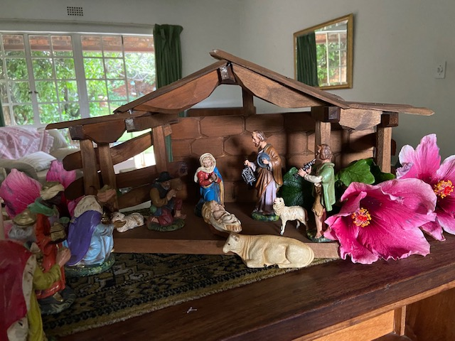

***Christmas message from Archbishop Anne – December 2022***

Christmas greetings from Johannesburg South Africa, where I have been for the last few weeks. This is probably the only time in my episcopacy that I will bring a Christmas message from the country of my birth. It is very strange being back here at this time of the year after so many years away.  For one thing, it doesn’t look anything like Christmas in the Northern Hemisphere and the temperatures hovering between 25 and 33˚C.  It’s summertime which means that children have started their long summer vacation.  Many families have vacated the cities for beach resorts, game reserves, or other holiday destinations.   
  
The other noticeable difference is that, because of the shortage of power across the country, there are virtually no Christmas lights to be seen strung outside peoples’ homes as we are so used to seeing in Canada. Most South Africans live behind high walls which means that you can’t see their houses at all, and any decorations or lawn ornaments they might have aren’t visible to passersby. It is only when you go into someone’s home, attend church, or go to the store that you know its ‘that time of the year again’. Christmas trees are decorated with baubles and tinsel. Battery operated lights twinkle brightly. Most of our family and friends have their nativity sets in place.

My brother Paul and I found our family’s much loved and well used crèche in one of mom’s closets as we were sorting through her things last week. This year it will have a new home at Paul and Tracy’s beginning a new Christmas tradition in their family. Seeing it again after all these years brought back memories of the years we, as young children, set it in place after listening to mom recounting the story of the Incarnation of our Lord Jesus Christ.   
  
As she proclaimed, like a deacon reading the gospel, each event in the unfolding story of mystery, wonder, and delight, we placed that character in the crèche. We marvelled at the messenger angels who interrupted lives bringing earth shattering news to a surprised Mary and a bewildered Joseph that Mary would carry the Son of God in her womb through the power of the Holy Spirit.  
  
We were enthralled as mom told of a host of angels lighting up the night sky above Bethlehem to bring good news to shepherds camping out in the veld that a Saviour had been born. We loved that they went immediately and eagerly in their search of the newborn babe and that when they found Jesus, Emmanuel, the Saviour of the world was lying in an animal’s feeding trough.   
  
We admired the perseverance of the Magi and the way they thwarted the wily King Herod, going home by a different way after offering their finest gifts to the Child. We knew the story by heart and over the years have told and retold it to our children. The tradition of telling the good news of Jesus birth was always told at home before we heard it in church.   
  
Perhaps your home was like ours where the baby Jesus was only placed in the manger after we had heard these or other sacred words about his nativity.

‘In the beginning was the Word, and the Word was with God, and the Word was God. He was in the beginning with God. All things came into being through him, and without him not one thing came into being. What has come into being in him was life, and the life was the light of all people. The light shines in the darkness and the darkness did not overcome it……And the Word became flesh and lived among us, and we have seen his glory, the glory as of a Father’s only Son, full of grace and truth.” (John 1.1-5, 14)  
  
In the prologue to his gospel, John is beginning a writing that is made up of words. He’s trying to communicate the most important meaning and truth that he knows, which he traces back to God.  At the very heart of his idea about God is the relationship of Jesus to his Father which is one of mutual in dwelling. The Father and the Son are utterly inseparable and the Son is close to the Father’s heart.

Love isn’t mentioned at all in the prologue, but the rest of John’s gospel makes it clear that the relationship between the Father and the Son is one of love. It is that unconditional kind of love that gives and gives and gives, and always sees the other before self. It is the kind of love God wants us to have with God and with others. You see, Love is at the very heart of everything for God. Without love nothing else matters. God’s love is expansive, inclusive, and inviting. God loves all things, all people, for all time.   
  
There is a beautiful movement in these opening words from John, from the breadth and expanse of creation to a desire for God to be close to us also - for us to live our lives close to the Father’s heart. And for us to go forward in the same kind of intimate relationship with Jesus that he had with his Father, learning who Jesus is through his story and then living in his Spirit.   
  
This is the invitation for us this Christmas - to open our hearts to Emmanuel, “God with us”, and to feel the love and the closeness of God that the Father and Son knew.  If we know that truth, we will be able to tell others the good news, as it was shared with us over and over again, that Emmanuel loves them and is always with them, as he is with you. May you and those you love remain close to the heart of God this Christmas and throughout the coming year.  
  
Colin and our whole family join me in wishing you every blessing of this holy season.  
Merry Christmas and a Happy New Year,  
  
***+Anne***