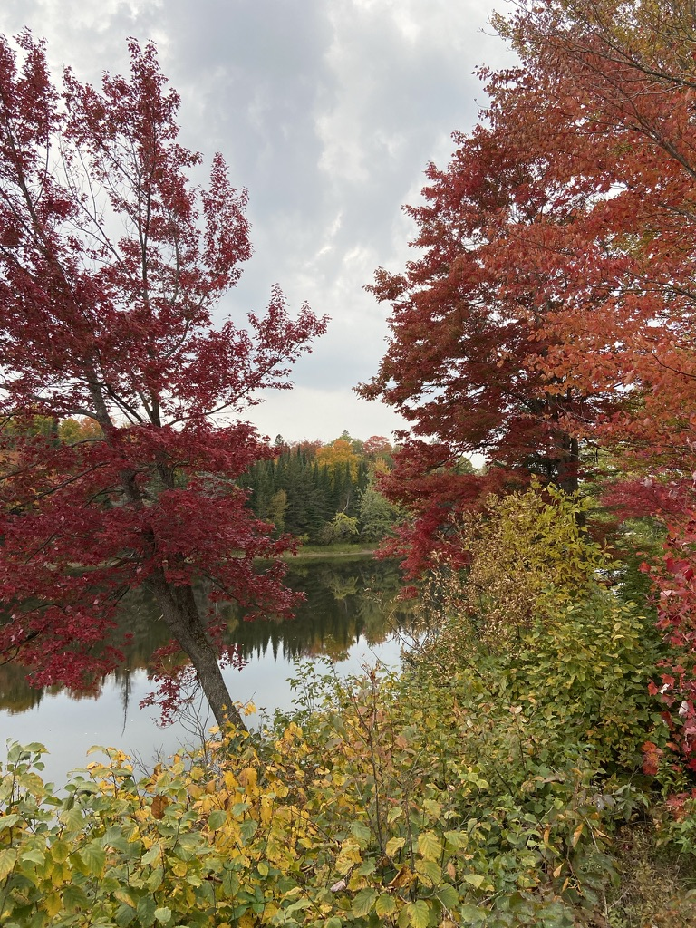

“Autumn is a second spring, when every leaf is a flower” (Camus)
Mississagi River near Blind River

Thanksgiving Message from Archbishop Anne
October 2022

“It is a good thing to give thanks to the Lord” (Psalm 92.1a)

Dear friends in Christ,

Sending warm wishes from our home and hearts to yours this Thanksgiving weekend. May the beauty of the season and the love of family and friends surround you as you count your blessings one by one.

I’ve been privileged to watch the changing season this year in four of Algoma’s deaneries and one of Moosonee’s as I’ve travelled to ten parishes for the celebration of Eucharist, that great act of Thanksgiving.

Travelling by road the leaves have been slowly changing from every shade of green to bright yellow and brilliant orange and red. The colours aren’t the only thing that are spectacular. The hills and lakes in the early morning are misty and the twilights linger longer. The fields that once held row upon row of corn are brown again and farmers are baling hay for the winter feeding. Canada geese and seagulls are there, pecking at the remains of the harvest.

There are freshly picked apples for sale at roadside stores, gourds at another, and the fruit of summer’s labour for sale at others. Travels always take a lot longer in the fall especially when harvesters block the highway. Next weekend I will be flying to Thunder Bay where I imagine the colours over Lake Superior will be magnificent.

The poet John Donne loved the fall – “No spring nor summer beauty hath such grace as I have seen in one autumnal face.”

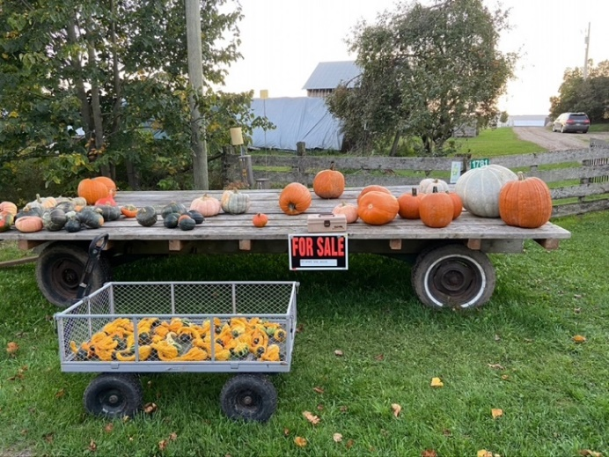
Gourds of all shapes and sizes for sale

While the journeys to various destinations were a treat, my heart was full to overflowing by what I experienced inside the doors of our church buildings.

There were the days of hearing stories of healing and learning from Fr. Michael Lapsley and his companion Philani when they visited from South Africa recently. Fr. Lapsley was an anti-apartheid activist in South Africa. He was exiled from that country to Zimbabwe and gravely injured when he opened a letter bomb. He lost both hands, an eye and part of his hearing in the blast.

Fr. Michael remained in hospital for more than seven months after he sustained those life-threatening injuries. As he recovered from his physical injuries he received artwork and cards from school children in North Bay where he had visited shortly before his injury. These simple acts of kindness and love helped Fr. Michael with his own healing and he went on to found the Healing of Memories Institute which offers workshops around the world for those suffering from trauma.

Fr. Michael was the key note speaker at our May clergy conference and spent four days in North Bay and Sudbury in September.

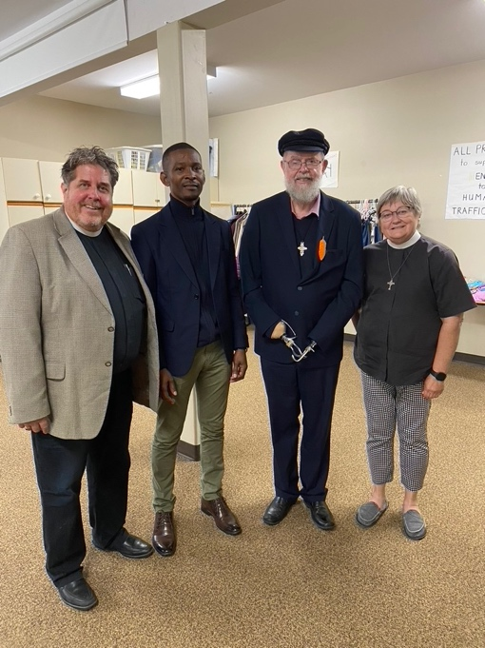
Fr. Michael Lapsley and his companion Philani with Archdeacons Jay Koyle and Joan Locke at Christ Church North Bay.

Then there were the celebrations of Holy Eucharist and Confirmation at All Saints’ in Huntsville, Christ Church, St. John’s and St. Brice’s in North Bay. Teenagers, newly baptized adults and those wishing to renew their commitments to Jesus Christ received strengthening in the life-giving, guiding gift of the Holy Spirit.

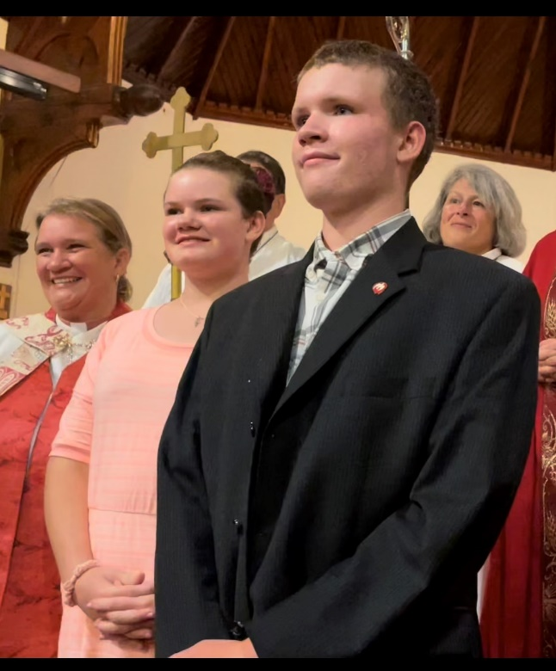
New confirmands at All Saints’, Huntsville
Claire and Gregory Baetz with mom, Archdeacon Kelly

There was the twice delayed 100th Anniversary celebration at Trinity All Saints in Bala, complete the blessing and dedication of doors and a new garden. New vestments were dedicated in memory of a much-loved priest and new Lay Readers were installed.
As Metropolitan, I was invited to celebrate and preach at a parish anniversary in Scarborough – Holy Trinity Guildwood and met new friends in the province.

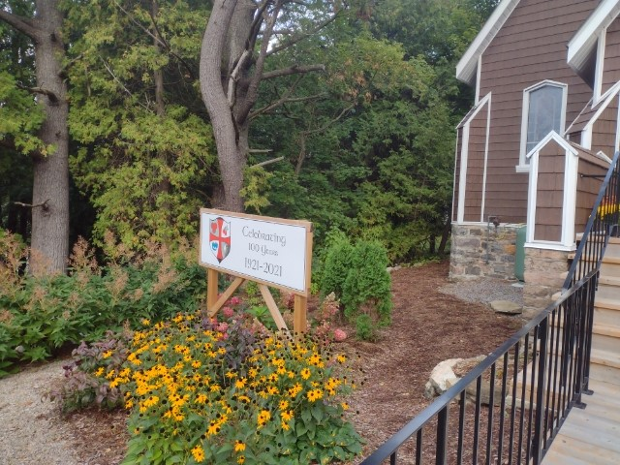
Trinity All Saints, Bala
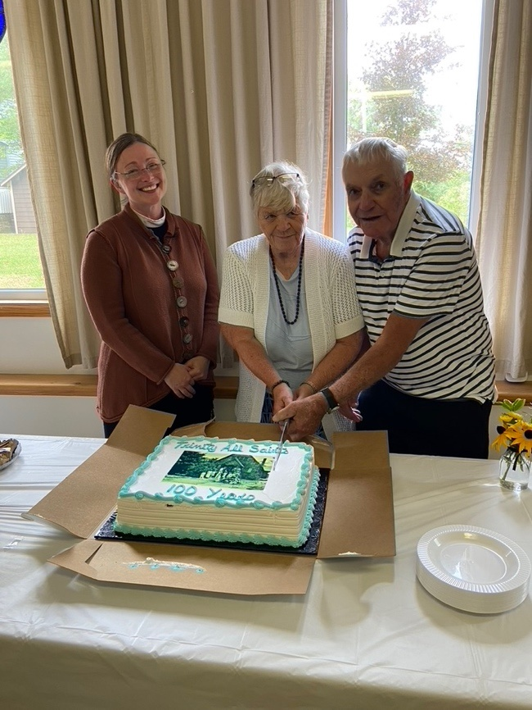
Rev. Heather Manuel and Norm and Jan Jackson, lifetime members of Trinity All Saints Bala, cut the cake at the parish’s 100th anniversary celebration in September.

Covid tried its best, but it did not stop the celebrations or the thanksgivings from flowing wherever I went. Thank you to everyone for making these visits so very special for everyone who attended. I am very aware of the work it takes to prepare for these occasions and am grateful to everyone involved, and also for the donations to my discretionary fund which I received.

There were services of thanksgiving and remembrance for her late Majesty Queen Elizabeth II at St. James Cathedral in Toronto, St. Luke’s Cathedral in Sault Ste. Marie, and a faithful priest in Moosonee at St. Matthew’s Cathedral. We lifted our voices to God in hymns of praise and prayers of gratitude for lives well lived.

There were dedications of trees in this year of the Treebilee in our own garden at Bishophurst in thanksgiving for Thorneloe University, for our ongoing commitment to Truth and Reconciliation and in thanksgiving for Queen Elizabeth II.

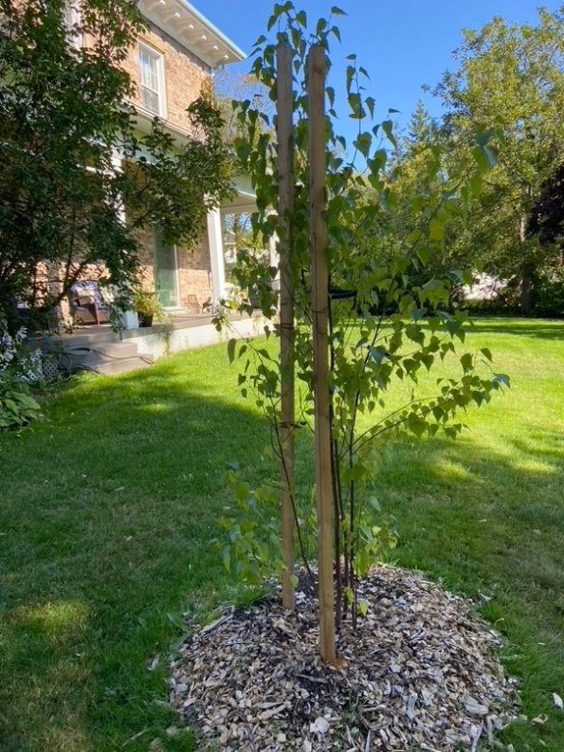
White Birch Tree in Bishophurst Garden, dedicated in the name of Truth and Reconciliation on the 2nd National TRC Day, September 30th.
Wood from the birch tree is used by Indigenous Peoples in Canada as the centre pole in teepees, the birch is symbolic of a new beginning.

This fall has been for me a long and lovely season of giving thanks with people in the pews, particularly after two years of lock downs and worshipping online. I recall with fondness the blessed memory of welcoming families for Thanksgiving services as they arrived at a church decorated with fresh flowers and produce from parishioners’ gardens.

I hope that sharing in common worship will be part of your Thanksgiving celebrations this year because we are changed from the inside out by every act of worship.

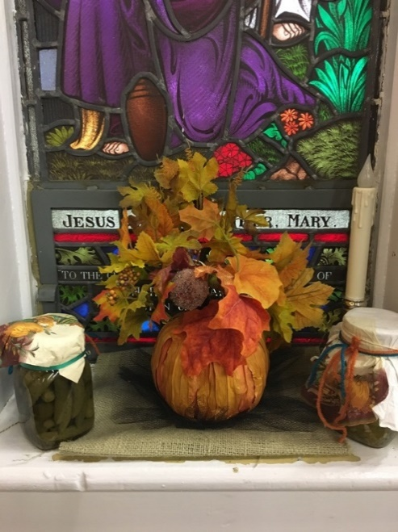
Harvest Thanksgiving at St. Mary Magdalene Sturgeon Falls
The 2nd Monday in October each year is set aside in Canada as a national day of Thanksgiving in observance of a tradition that is deeply rooted in our history and in the human desire to express gratitude.

Thanksgiving is also at the very heart of our lives as Christians and it is a spiritual act. Our principal act of worship when we gather on Sundays is an act of thanksgiving for what God has done for us in Jesus Christ. We offer this act of thanksgiving, this ‘sacrifice of praise and thanksgiving’ not only for ourselves but for the whole world.

Human hands bless bread and wine and through the Holy Spirit they are transformed into the body of Christ and his blood of a new covenant. Human hands receive this blessed gift and in the receiving of it through the gift of the Holy Spirit are transformed into holy people – the body of Christ ready to be sent out to be a blessing to the world.

We ought never to leave Church the same as when we entered it. The act of Thanksgiving changes us.

The Prayer of General Thanksgiving reminds us also that thanksgiving isn’t just for Sundays but for every day of the week. This magnificent prayer reminds us to give thanks for everything that God has done for us, and for all the blessings of this life, as well as everything that is wrong with them.

It is a perfect prayer for us to pray as we gather with family, friends and loved ones around a table laden with good food and for me to end this Thanksgiving message.
Accept, O Lord, our thanks and praise
for all you have done for us.
We thank you for the splendour of the whole creation,
for the beauty of this world, for the wonder of life,
and for the mystery of love.
We thank you for the blessing of family and friends,
and for the loving care
which surrounds us on every side.
We thank you for setting us tasks
which demand our best efforts,
and for leading us to accomplishments
which satisfy and delight us.
We thank you also for those disappointments and failures that lead us to acknowledge our dependence on you alone. Above all, we thank you for your Son Jesus Christ;
for the truth of his word and the example of his life; for his steadfast obedience,
by which he overcame temptation;
for his dying, through which he overcame death; for his rising to life again,
in which we are raised to the life of your kingdom. Grant us the gift of your Spirit,
that we may know Christ and make him known; and through him, at all times and in all places, may give thanks to you in all things. Amen.
+Anne: Algoma and Moosonee

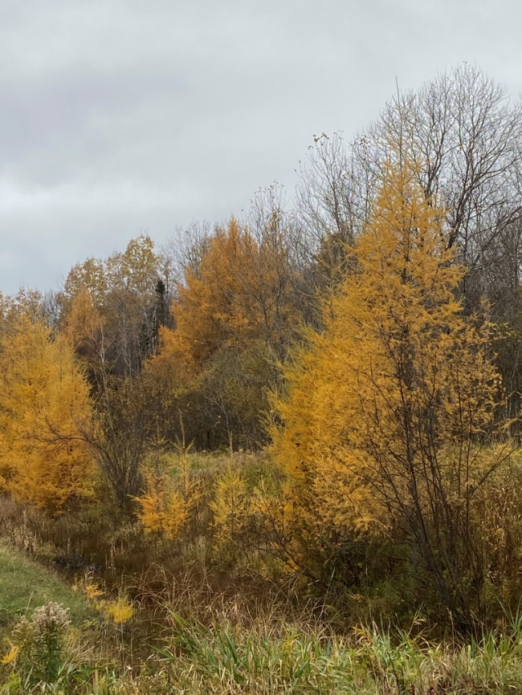
Tamaracks near our cottage on Bright Lake

“Autumn…the year’s last, loveliest smile”
William Cullen Bryant

