Call to Prayer – Lambeth Conference 2022

Archbishop Anne asks us to pray for her, our Primate, the Archbishop of Canterbury, and all the bishops of the Anglican Communion who are meeting currently in the 2022 Lambeth Conference, “God’s Church for God’s World.” Pray, too, for all who facilitate and provide support for the gathering.

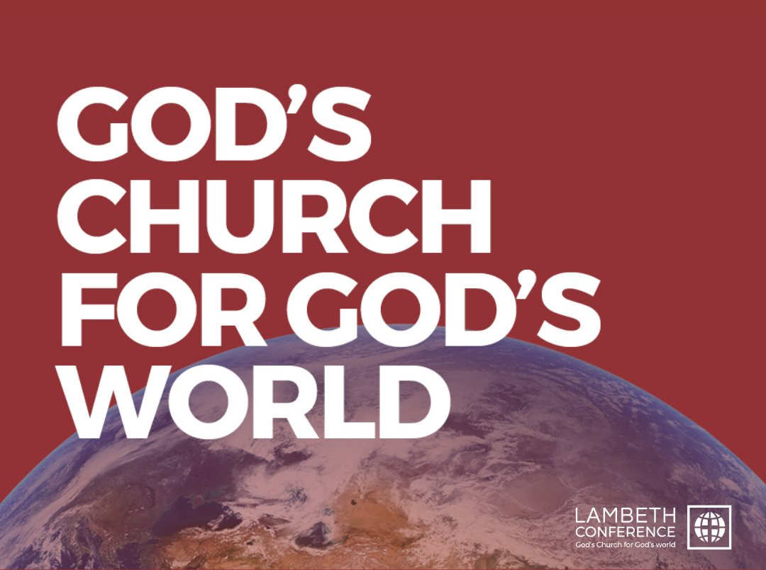

Below you will find a collect that may be used as the concluding collect to the Prayers of the People during the Eucharist or Sunday morning Liturgy of the Word, as a prayer included in Morning or Evening Prayer, or for use in households.

You also will find a bidding that may be included in the Prayers of the People (Eucharist; Liturgy of the Word) or Intercessions and Thanksgivings (Divine Office). Please feel free to adapt it to suit the form of the Prayers as they are used in a particular liturgy.

Finally there is a link providing various resources you can download and/or watch, a prayer rhythm guide, and a place to sign up to receive various resources and notifications throughout the conference.

For more information or if you have any questions, please contact Archdeacon Jay Koyle in the Synod Office.

An Algoma Collect for the Lambeth Conference

Praise be to you, God and Father of our Lord Jesus Christ,
for in your great mercy
you have given us new birth into a living hope
and into an inheritance that can never perish, spoil or fade.
Bathe with your Spirit of wisdom, courage, and compassion
Anne, our Archbishop and Metropolitan,
Linda, our Primate,
Justin, Archbishop of Canterbury,
and all the bishops of the Anglican Communion
who gather in this year’s Lambeth Conference.
Send your blessing, too,
upon all who facilitate and support their work.
Journeying together,
may all provinces of the Anglican Communion
forge a new vision that shapes us as a gospel people
and equips us to respond faithfully
to the needs of a 21st Century world.
We ask this through the One
who embodies your justice and peace,
Jesus Christ the Lord.

Bidding

For the world as it continues to face immense challenge with COVID-19, climate crisis, economic injustice, poverty, conflict, and inequality; that the bishops who gather in this year’s Lambeth Conference may forge a new vision which inspires hope, and equips us to respond faithfully to the needs of a 21st Century world, let us pray to the Lord:

Link to Prayer Resources Provided by Conference Organizers and Participants

https://www.lambethconference.org/resources/prayers/join-the-prayer-journey/

