Process Report of the Constitution and Canons Committee
for the Elections Committee
Diocesan Synod September 17 – 18, 2021

The Constitution and Canons Committee met by ZOOM on June 17, 2021. As requested by Archbishop Anne, we have developed a process for nominations for several elections that will take place during the virtual synod.

The elections for Synod, which are part of the Constitution and Canons, are as follows:

Delegates to General Synod
- The General Synod is scheduled for July 12-18, 2022 in Calgary.
- 2 Clergy, 2 Lay, and 1 Youth plus substitute delegates to be elected, from the members of synod

Delegates to Provincial Synod
- The Provincial Synod will be held by ZOOM on October 13-14, 2021.
- 4 Clergy, 4 Lay and 1 Youth plus substitute delegates to be elected, from the members of synod

Youth Member to the Executive Committee
- 1 youth to be elected, 1 alternate, from the youth delegates
- Nominations from the other youth delegates

Diocesan Court Members
- 1 cleric holding the bishop’s licence as deacon or priest for more than 5 years
- 2 lay who do not have to be members of synod

No nominations will be held during synod and nominations will all be obtained before September 17. This process meets the requirements of both the Constitution (Article 10 1.f) and the Canons (Canons A-6, A-7, and B-2) of the Diocese of Algoma, Constitution of the Anglican Church of Canada (Membership 8.f), and the Constitution of the Provincial Synod of the Ecclesiastical Province of Ontario (The Composition, Organization and Procedure of the Provincial Synod 1).

Two other elections will be held during synod. These elections are not in the canons.

Primate’s World Relief and Development Fund
- 1 representative

Bishophurst Maintenance Committee
- 2 members and 2 alternates who need to live in SSM but do not have to be members of synod

PROCESS

- All self-nominations to be received by the Elections Committee
(aka Jane Mesich treasurer@dioceseofalgoma.com) by Friday, July 30th
by completing and submitting the Candidate Information Form for Elections included with this document.
- The nominations to be sent out, along with background information about each candidate, in the Convening Circular mid-August, 2021

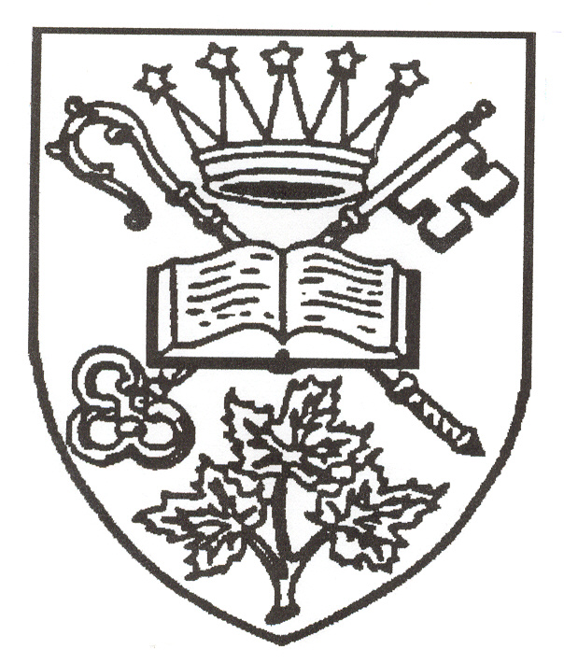
The Diocese of Algoma

Synod 2021

Elections:

General Synod

The next session of the General (national) Synod will meet in Calgary, July 12 - 18, 2022. Our Synod elects delegates and substitute delegates from among its members. Delegates may ask to be appointed to General Synod committees, or for election to the Council of the General Synod but this is not required of our delegates. Delegates serve a three year term from Synod to Synod.

One Youth Delegate and one alternate Youth Delegate are elected to represent Algoma at General Synod. The Youth Delegate must be over the age of 16 and under the age of 26 AT THE TIME OF GENERAL SYNOD.

Provincial Synod

The next session of the Provincial Synod will meet by ZOOM, October 10 - 12, 2021. Our Synod elects delegates and substitute delegates from among its members. One of our lay and one of our clergy delegates to the Provincial Synod will be chosen by our Provincial Synod delegates to join our Bishop in sitting as members of the Provincial Council. Delegates serve a three year term from Synod to Synod.

One Youth Delegate and one alternate Youth Delegate are elected to represent Algoma at Provincial Synod. The Youth Delegate must be over the age of 16 and under the age of 26 AT THE TIME OF PROVINCIAL SYNOD.

Diocesan Court

The Diocesan Court has been established to hear and determine all causes referred to it by the Bishop or Executive Committee for offenses against the provisions of the Constitution or Canons, the Provincial Synod of Ontario, or of the General Synod. The Diocesan Court shall hear and determine all other causes or questions referred to it by the Bishop or the Executive Committee.
The President of the Court is appointed by the Bishop and is a non-voting member. Our Synod elects one clerical and two lay members who then choose two other members to achieve a composition for the Court which is balanced in terms of gender, age, lay and clerical.
It is not anticipated that the Court will meet over the next two years, but its members must be in place in case this should prove necessary.

Primate’s World Relief and Development Fund Representative

Our Synod elects a representative who acts as liaison for the PWRDF within the diocese. There is an annual meeting in Toronto in the Fall.

Bishophurst Maintenance Committee

Our Synod elects two Members of the Bishophurst Maintenance Committee, along with two alternates. The Committee provides advice and assistance on the maintenance of Bishophurst, the Bishop’s residence in Sault Ste. Marie. Those elected do not need to be members of our Synod, but should be resident in Sault Ste. Marie.

Diocesan Executive Committee

The Diocesan Executive Committee meets three times a year from Synod year to Synod year. The meetings are usually held in Sudbury, mid-week for a day and a half. During the pandemic, the meetings have taken place over ZOOM. The Synod elects one Youth Delegate to represent them on the Executive Committee from nominations received from the youth.

THOSE WHO WISH TO STAND FOR ELECTION TO THESE OFFICES ARE INVITED TO COMPLETE THIS FORM. THE COMPLETED FORM NEEDS TO BE EMAILED TO THE SYNOD OFFICE BY JULY 30. PLEASE USE THE HEADINGS BELOW AND ATTACH A PHOTO (HEAD AND SHOULDERS).

The following example is given as a sample of what such a completed form could look like.

Name
Joan M. Smith

Office
Youth Member of the Executive Committee

Biographical Information (maximum of 50 words)
A longtime member of St. Cuthbert’s in Espanola who has served as a Youth Synod delegate for two years; a Diocesan Synod delegate this year; a member of the Youth Ministry Committee for three years. I have also worked on developing youth ministry within my parish.

Reasons for standing for Election (maximum of 100 words)
I am particularly interested in the increased involvement of youth within the Anglican Church locally and at the Diocesan level and feel I can make an important contribution representing our youth at the Executive Committee table. I am a first year university student residing within the Diocese of Algoma where I intend on finishing my four year program and, therefore, would be in touch with the issues/concerns being experienced within the Diocese of Algoma.

CANDIDATE INFORMATION FORM FOR ELECTIONS AT THE 2021 SYNOD

This form is provided for your convenience and the information does not need to be submitted on it. Candidates are at liberty to use any format they like, but it must include only the following information, be on a single sheet of paper, and not exceed the maximum word limit.

Name

Office

Biographical Information (maximum of 50 words)

Reasons for standing for Election (maximum of 100 words)

