February 27 2021
Dear Lay Readers and friends,

We are pleased to announce that we will be having a five-day Summer Fruit for Souls conference this summer from Monday July 19 to Friday July 23, 2021. In the interests of our safety the conference will be virtual, using Zoom as a platform, which is what we are all getting used to!

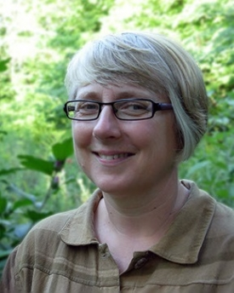
Our keynote speaker will be Dr. Sylvia Keesmaat, who taught Biblical Studies and Hermeneutics at the Institute for Christian Studies for ten years. In 2004 she left full-time academia to pursue her interests in sustainable living. Her topic will be:

On Earth as In Heaven: The Coming of the Kingdom
When we pray “Your kingdom come, on earth as it is in heaven,” what exactly are we hoping for? Beginning with our calling to live as a community of God’s image bearers on earth, we will explore how the future hope for God’s kingdom on earth nourishes and sustains our calling in the present.

As well as lectures, break out rooms and discussions, we will endeavour to have conversations, worship, singing and fun with one another. In other words, we will try to incorporate many of the elements of Summer Fruit that we love, all enjoyed in the comfort and safety of our own homes.

Enrolment is unlimited and the registration fee is only $75.00. Registrants will receive further information closer to the date. Meanwhile, please save the date, and spread the word. Any lay person is welcome to attend.
Yours in Christ
Mary

Mary Raddon, Coordinator,
Summer Fruit for Souls
Anglican Diocese of Ontario

