Agapé for Maundy Thursday
This order of worship for Maundy Thursday is within the context of an Agape Meal to be eaten in homes, and perhaps with others in a congregation or the wider church that join together online from their homes. It may also be adapted so the Proclamation of the Word is observed by the congregation online, followed by the footwashing and meal in households.
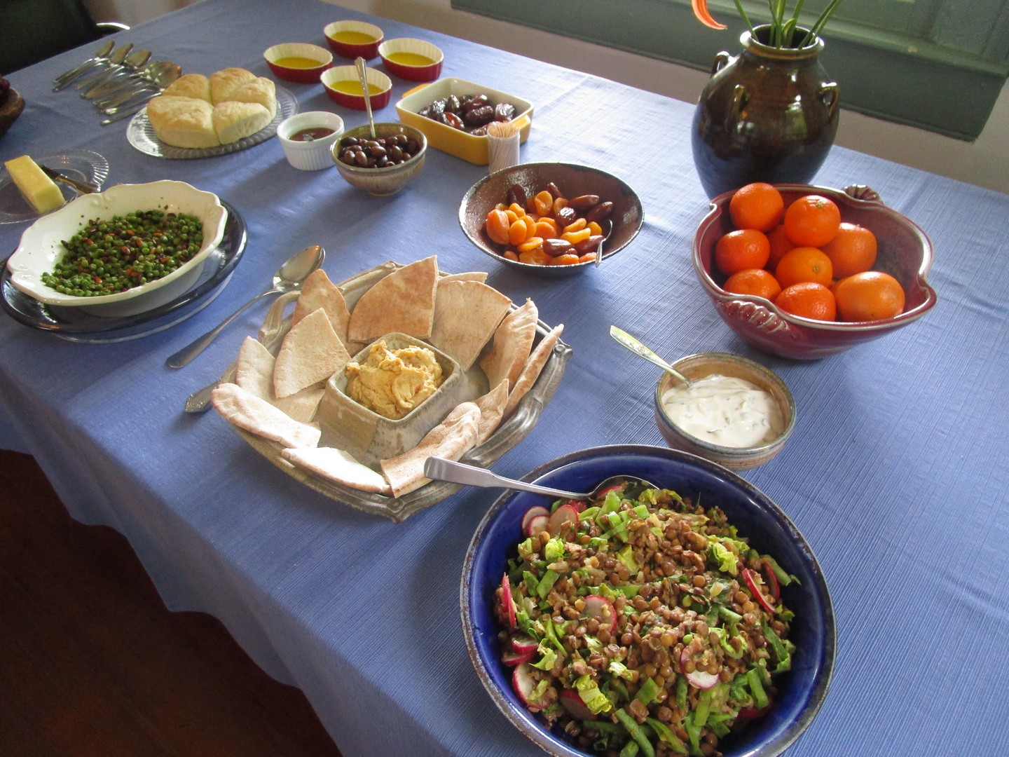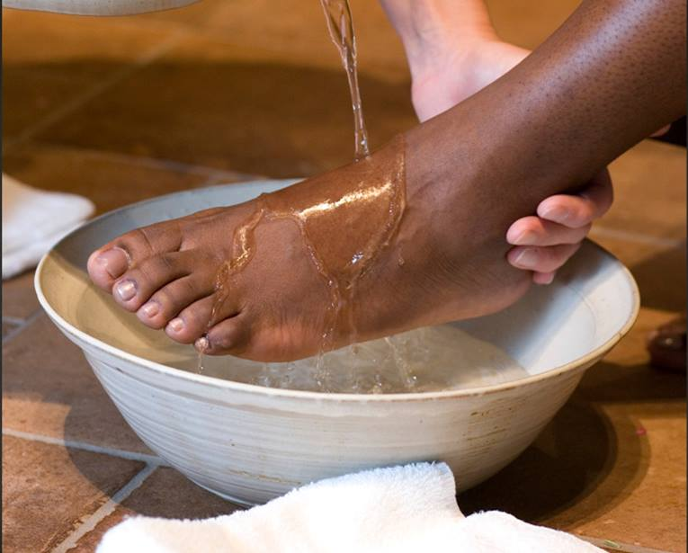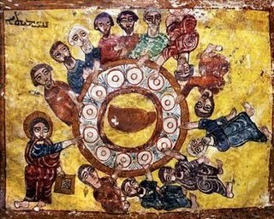
(Note: More than one household could prepare for this service and coordinate their shared celebration using a video conferencing platform.)
For the sake of simplicity for both ritual and technological reasons, if there are several persons present or more than one household participating, one individual should serve as presider.
On the night of his betrayal, Jesus shared a meal with his disciples. He shared this meal in the home tradition and setting of the Passover meal. The washing of feet, the sharing of bread and wine, and the new commandment to love one another all happened in a home, in a room where Jesus drew his friends together as host, teacher, friend, and master who was there to serve them all.
This evening marks the beginning of the Three Day celebration of Christian Passover. During this extraordinary time that requires us once again this year to practice social distancing in order to help protect everyone from the spread of the COVID-19 virus, we are being taken back to our households as our base-point. But many of us have the blessing in this technological age of joining others in fellowship even when we are alone in our households. We can join now with each other on this holy night, as we pray, sing, and hear the Word of God while we eat together, each in our own homes but joined in fellowship.
This service also acts as a call to the revitalization of the domestic church, a notion of which the Church has lost sight over the past few generations. In addition, it recognizes the profound connection between the Celebration of the Eucharist and the meals we share in daily life. Therefore, though this rite is not the sacrament of the Eucharist, it reminds us of the holiness, the “sacramentality” of all meals, the holiness of all food, and the presence of the Risen Christ whenever we break bread.
This service weaves together parts of the Maundy Thursday liturgy with aspects of the Agape Meal as outlined in the Book of Occasional Services of The Episcopal Church (2018). (An Agape meal is an ancient feast of a communal meal shared by Christians, ‘agape’ - a-ga-pay - being a Greek word that reflects God’s unconditional love.) This service may include the washing of feet in households where there are two or more people.

To make ready your home for the service, please do the following –
- Prepare a simple meal to share in your home that is fitting with your own dietary requirements and Lenten fast. Salads, soups, fruits and nuts, and simple grains or pastas can all be fine. Include a bit of bread and wine, according to what is in keeping with your dietary requirements.
- Set your space for your meal, including a Bible and a couple of candles. If you are connecting with other households via a laptop, tablet, cell phone, land-line (hopefully with speaker phone), or internet-connected screen in the room, make sure it is where it can be audible and visible to everyone during the meal. Many people will have had opportunities over this past year to test their sound and video input and output on their devices.
- If observing the footwashing, set up what you need to wash each other’s feet. A washbasin, a pitcher with warm water, and a few towels are sufficient. Make sure there is a chair by the basin where people can sit when their feet are washed. If you wish to use a bit of soap or fragrance oil, feel free. Set a foot-washing space in the room, just a bit away from the table. Have what you need for good washing and drying of hands at a nearby sink. Even if not observing the footwashing, you may wish to have a basin and pitcher nearby as a visual reminder of one of the key actions of this night.
- If you are eating this meal on your own, feel free to adapt the rite by leaving out the dialogues between Presider and People. You may wish to leave out other texts as seems appropriate, or alter them to speak in singular voice. The prayers, however, should continue to be plural in reference, as you are praying with the wider church.
- Please remember that appropriate adaptations for illness in the household should be made.

+ The Gathering +
Presider: The grace of our Lord Jesus Christ, and the love of God,
and the fellowship of the Holy Spirit be with you all.
People: And also with you.

Presider: As we enter the Great Three Days of Christian Passover,
hear these words from the Book of Exodus.

Reader: The LORD said to Moses and Aaron in the land of Egypt:

This month shall mark for you the beginning of months;
it shall be the first month of the year for you.
Tell the whole congregation of Israel that on the tenth of this month
they are to take a lamb for each family,
a lamb for each household.
If a household is too small for a whole lamb,
it shall join its closest neighbour in obtaining one;
the lamb shall be divided
in proportion to the number of people who eat of it.

This is how you shall eat it:
Your loins girded, your sandals on your feet,
and your staff in your hand;
and you shall eat it hurriedly.
It is the passover of the LORD.
For I will pass through the land of Egypt that night,
and I will strike down every firstborn of the land of Egypt,
both human beings and animals;
on all the gods of Egypt I will execute judgments:
I am the LORD.

The blood of the lamb on the doorposts and the lintel
shall be a sign for you on the houses where you live:
when I see the blood, I will pass over you,
and no plague shall destroy you when I strike the land of Egypt.

This day shall be a day of remembrance for you.
You shall celebrate it as a festival to the LORD;
throughout your generations you shall observe it as a perpetual ordinance.

Presider: Let us pray. (Allow a brief time of silence before starting the prayer.)

Holy God, source of all love,
on the night of his betrayal,
Jesus gave us a new commandment,
to love one another as he loves us.
Write this commandment in our hearts,
and give us the will to serve others
as he was servant of all,
your Son, Jesus Christ, our Saviour and Lord,
who lives and reigns with you and the Holy Spirit,
one God, now and forever.
People: Amen.

If the Proclamation of the Word is observed online with the congregation,
it may precede the Blessings and Meal.
The Exodus reading is omitted above and proclaimed as the first reading.

+ The Blessings +

When the table has been set, all gather around the table, standing as able.

After a time of silence, the Presider offers the following blessings.

Over Wine
Blessed are you, O Lord our God, Ruler of the universe. You create the fruit of the vine; and you refresh us with the cup of salvation in the Blood of your Son Jesus Christ. May the time return quickly when we can share that cup again, even as you are with us now in our very thirst for you. Glory to you for ever and ever. Amen.

Over Bread
Blessed are you, O Lord our God, Ruler of the universe. You bring forth bread from the earth; and you have fed us on our way with the bread of life in the Body of your Son Jesus Christ. Let us be fed again soon with that bread of life. As grain scattered upon the earth is gathered into one loaf, so gather your Church in every place into the kingdom of your Son. To you be glory and power for ever and ever. Amen.

Over the Other Foods
Blessed are you, O Lord our God, Ruler of the universe. You have blessed the earth to bring forth food to satisfy our hunger. Let this food strengthen us in the fast that is before us, that following our Savior in the way of the cross, we may come to the joy of his resurrection. For yours is the kingdom and the power and the glory, now and for ever. Amen.

+ The Meal +

The meal is now eaten. If several are gathered, they first serve one another,
then dine.

If the Proclamation of the Word is observed online with the congregation,
it may precede the Blessings and Meal.

+ The Word and the Prayers +
At the end of the meal, someone reads John 13.1-17.
This scripture passage may be read from your Bible or using the copy of the passage provided as an appendix to this service.
If there is to be a footwashing, it takes place immediately after the reading. Simply move to where the basin, pitcher, and towels are placed. The Presider starts the footwashing. Then those present may wash the feet of one another. This action should include no conversation, and be carried out in silence. When the footwashing is finished and all participating have washed their hands, people return to the table.
A simple hymn, song, or refrain may be sung.

Prayers of the People

Presider: I invite each and all of you to name those people and places
for whom we should pray and remember this night.

Time is allowed for people to do so.

The Presider concludes with the following prayer:

Presider: Infinite, intimate God,
your Son Jesus Christ girded himself with a towel
and washed his disciples' feet.
Hear the prayer we offer in his name,
and grant us the will to be the servant of others
as he emptied himself to become the servant of all,
who gave up his life and died for us,
yet lives and reigns with you and the Holy Spirit,
one God, now and for ever.
People: Amen.

After a brief time of silence, people may say “good night” to those with whom they shared this time online or over the phone.

Before the silence and ‘goodnight, or as the table is cleared and clean up takes place in each household, participants are encouraged to reflect upon the service, addressing questions like:

What stands out to you from what we did tonight? What did you notice?

Was there a moment you felt particularly close to God or one another?

What do you think might be the connection between footwashing and the Eucharist?
How about the connection between our family meals and the Eucharist with the church?

How might Jesus be inviting you to serve others in your actions?

Portions of this rite have been provided by and/or adapted from the Rev. Dr. James Farwell and Dr. Lisa Kimball of Virginia Theological Seminary, and The Rev. Dr. David Gartner, Diocese of Spokane, The Episcopal Church. Used with permission.

Collect of the Day from The Book of Alternative Services, copyright © 1985 by the General Synod of the Anglican Church of Canada. All rights reserved. With permission under license from ABC Publishing, Anglican Book Centre, a ministry of the General Synod of the Anglican Church of Canada, from Anglican Liturgical Library.

The reading from Exodus, from the New Revised Standard Version of the Holy Bible, copyright © 1989 the Division of Christian Education of the National Council of the Churches of Christ in the United States of America. Used by permission. All rights reserved.

Appendix: John 13.1-17

Jesus Washes the Disciples’ Feet
13 Now before the festival of the Passover, Jesus knew that his hour had come to depart from this world and go to the Father. Having loved his own who were in the world, he loved them to the end. ² The devil had already put it into the heart of Judas son of Simon Iscariot to betray him.
During supper ³ Jesus, knowing that the Father had given all things into his hands, and that he had come from God and was going to God, ⁴ got up from the table,^{[a]} took off his outer robe, and tied a towel around himself. ⁵ Then he poured water into a basin and began to wash the disciples’ feet and to wipe them with the towel that was tied around him. ⁶ He came to Simon Peter, who said to him, “Lord, are you going to wash my feet?” ⁷ Jesus answered, “You do not know now what I am doing, but later you will understand.” ⁸ Peter said to him, “You will never wash my feet.” Jesus answered, “Unless I wash you, you have no share with me.” ⁹ Simon Peter said to him, “Lord, not my feet only but also my hands and my head!” ¹⁰ Jesus said to him, “One who has bathed does not need to wash, except for the feet,^{[b]} but is entirely clean. And you^{[c]} are clean, though not all of you.” ¹¹ For he knew who was to betray him; for this reason he said, “Not all of you are clean.”
¹² After he had washed their feet, had put on his robe, and had returned to the table, he said to them, “Do you know what I have done to you? ¹³ You call me Teacher and Lord—and you are right, for that is what I am. ¹⁴ So if I, your Lord and Teacher, have washed your feet, you also ought to wash one another’s feet. ¹⁵ For I have set you an example, that you also should do as I have done to you. ¹⁶ Very truly, I tell you, servants^{[d]} are not greater than their master, nor are messengers greater than the one who sent them. ¹⁷ If you know these things, you are blessed if you do them.

New Revised Standard Version of the Holy Bible, copyright © 1989 the Division of Christian Education of the National Council of the Churches of Christ in the United States of America. Used by permission. All rights reserved.

