The Most Reverend Anne Germond
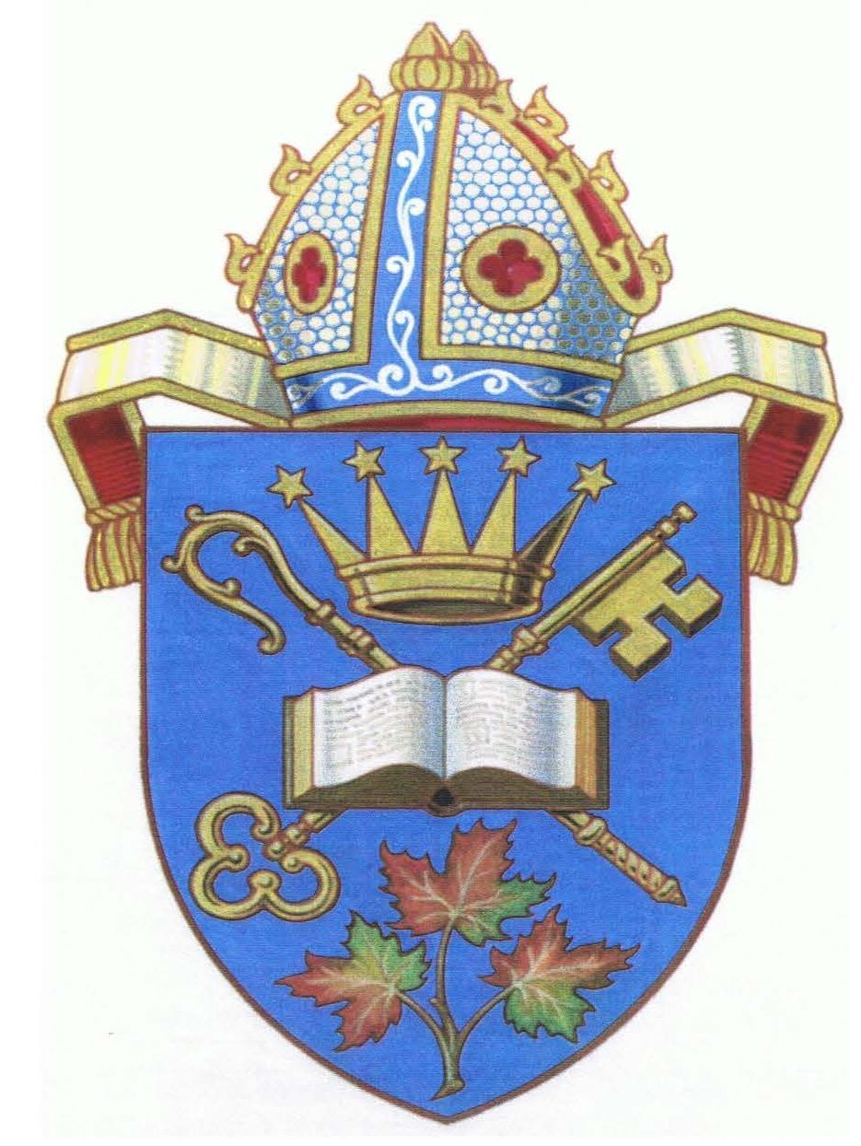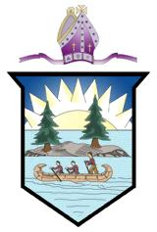
DIOCESE OF ALGOMA DIOCESE OF MOOSONEE
619 Wellington Street East 2-113 B Third Street West
Sault Ste. Marie, ON P6A 2M6 Cochrane, ON P0L 1C0

Updated RED Stage Protocols for “Loving our Neighbours”
Dioceses of Algoma & Moosonee
Effective February 16, 2021

The following protocols and all directives of the Government of Ontario (and Quebec where applicable), and local health authorities must be followed at all times, including the foundational pandemic hygiene guidance of handwashing, staying home if feeling sick, practicing physical distancing, and wearing a face covering. Always follow the directives that provide the most protection when there is a discrepancy between diocesan and government/local health unit protocols.
- Corporate worship continues to be livestreamed or pre-recorded and made available online. The maximum for indoor or outdoor gatherings for worship is ten persons, where permitted by government/local heath unit directives.
- Parish meetings should take place online.
- Small weddings, funerals, and emergency baptisms are permitted.
- The season of Lent is a time of preparation for baptism. Therefore the dispensation allowing for baptisms at home in the Diocese of Moosonee is suspended during Lent.
- Essential one-on-one, in person pastoral care by clergy and pastoral visitors is permitted. Each area hospital, nursing home and hospice has its own guidelines. These are to be followed at all times.
- Offices may reopen for staff and lay leaders where physical distancing is possible. Masks are to be worn at all times in shared spaces.
- Vital food security, community and other outreach ministries to vulnerable populations are permitted to operate, with appropriate diocesan/local public health approval.
- Church buildings are closed to the public, except in circumstances where tenants or licenses are permitted to operate according to provincial, local, and diocesan guidelines.
- Food and beverages are not to be served or shared.

