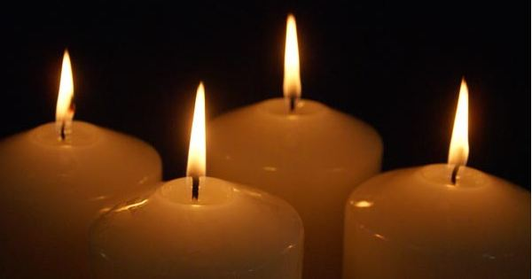

Blue Christmas

A Service of Prayer and Reflection for when Christmas is a Difficult Time

ALL SAINTS ANGLICAN CHURCH
HUNTSVILLE ONTARIO

Prelude Music
Welcome

Call to Prayer
Loving God,
You have brought us to this holy place,
With our sorrows and cares.
Quiet our minds,
Help our bodies to rest,
Let our spirits be open to finding peace.
As the darkness of evening surrounds us,
Let light fill our hearts,
Open our minds and spirits
Allowing Jesus to be born into our lives.
Amen
Reading 1: Isaiah 40:1-11

Comfort, O comfort my people,
says your God.
Speak tenderly to Jerusalem,
and cry to her
that she has served her term,
that her penalty is paid,
that she has received from the Lord’s hand
double for all her sins.
A voice cries out:
“In the wilderness prepare the way of the Lord,
make straight in the desert a highway for our God.
Every valley shall be lifted up,
and every mountain and hill be made low;
the uneven ground shall become level,
and the rough places a plain.
Then the glory of the Lord shall be revealed,
and all people shall see it together,
for the mouth of the Lord has spoken.”
A voice says, “Cry out!”
And I said, “What shall I cry?”
All people are grass,
their constancy is like the flower of the field.
The grass withers, the flower fades,
when the breath of the Lord blows upon it;
surely the people are grass.
The grass withers, the flower fades;
but the word of our God will stand forever.
Get you up to a high mountain,
O Zion, herald of good tidings;
lift up your voice with strength,
O Jerusalem, herald of good tidings,
lift it up, do not fear;
say to the cities of Judah,
“Here is your God!”
See, the Lord God comes with might,
and his arm rules for him;
his reward is with him,
and his recompense before him.
He will feed his flock like a shepherd;
he will gather the lambs in his arms,
and carry them in his bosom,
and gently lead the mother sheep.

Reading 2: John 14:15-21

“If you love me, you will keep my commandments. And I will ask the Father, and he will give you another Advocate, to be with you forever. This is the Spirit of truth, whom the world cannot receive, because it neither sees him nor knows him. You know him, because he abides with you, and he will be in you.
“I will not leave you orphaned; I am coming to you. In a little while the world will no longer see me, but you will see me; because I live, you also will live. On that day you will know that I am in my Father, and you in me, and I in you. They who have my commandments and keep them are those who love me; and those who love me will be loved by my Father, and I will love them and reveal myself to them.”

Reflection

A Litany of Remembering *

The leader lights each Advent candle in turn

Leader: We light this candle to remember those whom we have loved and lost. We pause to remember their names, their faces, their voices, and the memories that bind them to us in this season.
People: May God's eternal love surround them.

Moment of silence

Leader: We light this candle to redeem the pain of loss we may have experienced: the loss of a relationship, the loss of work, the loss of health, the loss of faith. We pause to feel the pain of the loss whether in our hearts, our bodies, our minds. We reach up, offering our pain to God, asking that from God's hands we receive the gift of peace beyond understanding.
People: Refresh, restore, renew us O God, and lead us into your future.

Moment of silence

Leader: We light this candle to reflect on the specific struggles of this year; for the shared pain visited in different ways upon all of us by this pandemic time. We admit our frustration that Christmas, already such a hard time for so many people, is in some ways even more difficult now. We give thanks for the remembrances of hugs, visits, handshakes, and presence with friends, families, and those new to us who have shared the gift of gentle support.
People: Let us remember that dawn defeats darkness.

Moment of silence

Leader: We light this candle to renew our faith and the gift of hope, and
rebirth, which the Christmas story offers to us. We remember
that the God who shares our lives promises a place and time where
there is no more pain or suffering in mind, body and soul.
People: Let us remember the one who shows the way, who brings the
truth and who bears the life.

Moment of silence

Songs/Instrumental music as individuals are invited to reflect and pray quietly.

Closing

God of compassion and love,
Unseen you are present—
You hear our cries of distress,
You give us strength to bear burdens that overwhelm us,
Your healing touches us when we are broken,
Your peace reveals wholeness in the midst of turmoil,
Your love fills the empty spaces in our lives.
Glory to God from whom all life flows,
Glory to Jesus, who showed his love by living as one among us,
Glory to the Holy Spirit, who fills our lives with light.
Amen.

Many thanks to our musicians.

*The litany has been adapted from San Carlos United Methodist Church in San Diego. The order of service may be found at:
http://www.mentalhealthministries.net/links_resources/worship_resources.html

