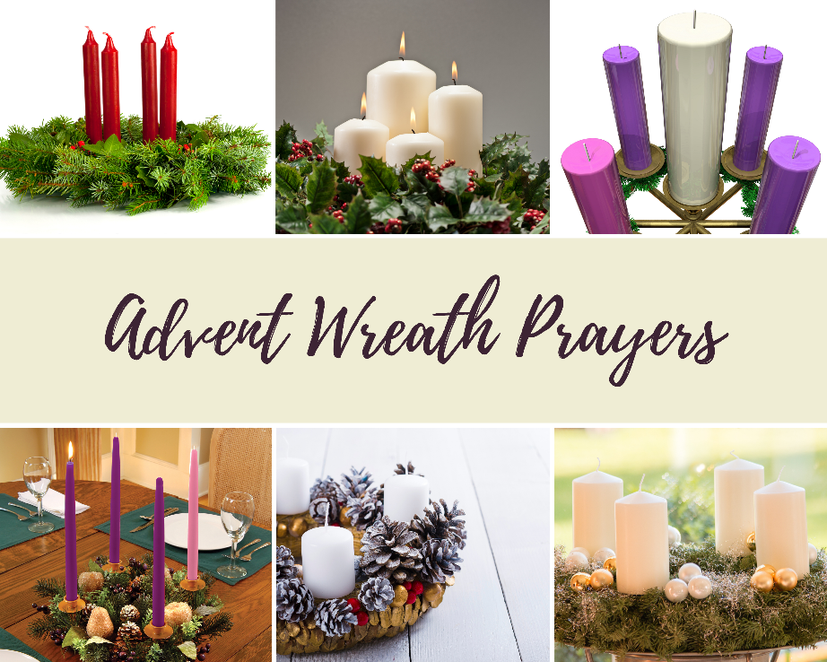
(This resource originally put together by St. Stephen the Martyr Anglican Church, Burnaby, BC, and shared with permission. Adaptations made for local context).

The Advent wreath marks the passage of the weeks of the season of Advent. It was originally devised to encourage family observance of Advent and was introduced to congregational worship only to provide a model for family use.

The lighting of one, two, three, then four candles during the weeks of Advent is a reminder that we await Jesus Christ, the Light of the World. To wait for Jesus is to be ready to meet him in all the ways he comes. It is important that Christians observe Advent not only as a time of preparation for Christmas but also in realization that Christ’s coming kingdom stands in judgement over the injustices of our present world.

For many years, the church often used a dark “royal” purple for the liturgical colour of Advent and, therefore, for three of the candles on Advent Wreaths. In more recent years, there has been a reclaiming of a deep blue for the season. Both colours symbolize preparation, penitence, and royalty to welcome the new King.
Deep blue is the color of the clear, predawn sky, the color that covers the earth in the hours before the sun rises in the east. Most of us are not looking at the sky at that hour – perhaps we’re still asleep, or too weary to notice it as we get ready for work or school. Nonetheless, a deep, dark blue is the color that covers us in the dark, cold hours before the sun dawns. Thus, the deep blue for Advent reminds us of the season of expectation and anticipation of the dawn of Christ.

The fourth candle is pink and is lit on the Third Sunday of Advent when we celebrate with special joy. Some people light a white candle, the Christ candle, in the center of the wreath on Christmas Day.

{Explanations from The Book of Occasional Services, Anglican Church of Canada and Faithful Celebrations: Making Time for God from Advent Through Epiphany edited by Sharon Ely Pearson}
A Suggestion for At Home Prayer and Conversation with an Advent Wreath
{from Seamless Faith: Simple Practices for Daily Family Life by Traci Smith}

Light the Candles:
- Decide which day and time the candles will be lit during Advent. Choose a consistent time for each of the four weeks.
- Gather everyone together with a special dessert (suggestions include candy canes, hot cocoa, cookies, ice cream).
- Light the candle of the corresponding week (as well as the candles from the previous week[s]) and follow the readings below. Take turns reading and lighting the candle(s) from week to week. Candles can remain lit for the evening until the last adult goes to bed.
Week 1 – Hope: The leader says, “This is the first week in Advent, and we light the candle of hope.” The leader lights the first candle and asks, “What does it mean to have hope as we wait for Jesus’ birth?”

Everyone takes turns answering the question while enjoying the dessert. Family members can take the conversation wherever it leads. At the conclusion of the sharing time, someone says, “Let us leave with hope in our hearts.”

Week 2 – Peace: The leader lights the first candle, then says, “This is the second week of Advent. Last week we lit the candle for hope. This week we light the candle of peace.” The leader lights the second candle, and asks, “What does it mean to have peace as we wait for Jesus’ birth?”

Everyone takes turns answering the question while enjoying the dessert. Family members can take the conversation wherever it leads. At the conclusion of the sharing time, someone says, “Let us leave with hope and peace in our hearts.”

Week 3 – Joy: The leader lights the first two candles and then says, “This is the third week in Advent. We have already lit the candles for hope and peace and today we light the candle of joy.” The leader lights the third candle and asks, “What does it mean to have joy as we wait for Jesus’ birth?”

Everyone takes turns answering the question while enjoying the dessert. Family members can take the conversation wherever it leads. At the conclusion of the sharing time, someone says, “Let us leave with hope, peace, and joy in our hearts.”

Week 4 – Love: The leader lights the first three candles and then says, “This is the fourth week in Advent. We have already lit the candles for hope, peace, and joy. Today we light the candle of love.” The leader lights the fourth candle, and asks, “What does it mean to have love as we wait for Jesus’ birth?”

Everyone takes turns answering the question while enjoying the dessert. Family members can take the conversation wherever it leads. At the conclusion of the sharing time, someone says, “Let us leave with hope, peace, joy, and love in our hearts.”

Christmas Eve: The leader lights the four candles and says, “Tonight is Christmas Eve. We have already lit candles for hope, peace, joy, and love, and we have talked about what it means to have these things as we wait for Jesus’ birth. Today we celebrate the coming of Christ into the world and we light the Christ candle.” The leader lights the Christ candle, and asks, “As we think about Christmas, how do we experience the hope, peace, joy, and love of Jesus in our lives?”

Conclude the Christmas Eve sharing time by singing “Silent Night” and saying Merry Christmas to one another.

Note: The questions for each week are deliberately simple, open-ended, and repetitive. If the response is thin the first year, remind family members that next year the same question will be asked. They might have more to say the next year.

Some Adjustments You Might Find Helpful
This suggestion is designed as an evening ritual for families with verbal, school-aged kids. Your circumstances may be different, but lighting each candle, week-by-week and taking some time to contemplate the themes can be a powerful way to mark the season, counter the consumption-heavy Christmas prep, and try-on a contemplative prayer practice. You could certainly use the same ritual in the morning, as a lunch-time practice, or during a mid-afternoon break.

One guide for prayers at any time is the “Home Prayers” included in the Book of Alternative Services (known as BAS) beginning on page 687. The BAS is the green book from which we draw much of our Sunday liturgy. If you do not have one, you can access it online at anglican.ca/liturgicalresources.

If you are alone: You might want to simply sit with the question each week. Perhaps set a timer or use a piece of music to create a space for reflecting. Writing or drawing can be useful tools for reflection. Don’t worry too much if your mind wanders. If you are new to contemplative practice, even 2 or 3 minutes of sitting in stillness can seem very long and is enough.

Connecting Virtually: This format could be used during a weekly video or audio call with relatives or friends. This might be fun to do with a grandchild or among cousins. Two friends might commit to having the same time of contemplation and then sharing a phone call to talk about what came up.

Alternatives to Sweet Treats: Because this suggestion is designed with families in mind as a kind of after-dinner ritual, the suggestion is to share a special dessert during the time. That can be a great way to help mark the time – and give participants something to do with their hands and mouths while they think. But a good cup of tea works too! It can, obviously, also be done without eating or drinking.

Adding Scripture: If you are in an adult-only home or sharing this ritual with older children or teenagers, it might be worthwhile to read a short bit of Scripture as a part of your time. You could use the readings assigned for each Sunday. You’ll find those below. You could also read through the Gospel of Mark.

Christmas Eve: Depending on when you are lighting your Advent Wreath, you might light your Christ Candle in the evening of Christmas Eve or the morning of Christmas Day. This might also have to do with your other Christmas commitments.

Ending The Time: You may find the suggested closing needs modification. Perhaps the literalist in your home objects to the term “leave” for just moving from your dining table into bedtime routine. Doing this alone as a contemplative practice might call forth a feeling of wanting a slightly longer prayer. You’ll find a prayer for each week below.

First Sunday of Advent  November 29, 2020  Theme: Hope | Readings  Isaiah 64: 1-9  Psalm 80: 1-7, 17-19  Mark 13: 24-37 | God of hope, in times of darkened sun and wanning moon, lift up our hearts and waken our love that we might cling to your advent promise that we will walk in the way of Christ, whose coming is certain and whose day draws near. Amen.
Second Sunday of Advent  December 6, 2020  Theme: Peace | Readings  Isaiah 40: 1-11  Psalm 85: 1-2, 8-13  Mark 1: 1-8 | God of these short days and long nights, your word stirs within us the dream of a dawn filled with unexpected peace. Remove those things which hinder our love of you so that we may wait in awe and wonder for the One who is peace now and for ever.
Third Sunday of Advent  December 13, 2020  Theme: Joy | Readings  Isaiah 61: 1-4, 8-11  Psalm 126  John 1: 6-8, 19-28 | God of holy joy, in this season of festivity and cheer, strengthen our hearts that our mouths may be filled with songs of praise announcing glad tidings of peace and welcoming Christ into our midst.
Fourth Sunday of Advent  December 20, 2020  Theme: Love | Readings  2 Samuel 7: 1-11, 16  Luke 1: 46b-55  Luke 1: 26-38 | God whose love knows no boundaries, grant us courage to carry your Word within our hearts that we may be dwelling places for the One who was and is and is to come.
Christmas Eve/Day  December 24/25, 2020 | Readings  Isaiah 52: 7-10  Psalm 98  John 1: 1-14 | Eternal God, this holy night [day] is radiant with the brilliance of your one true light. May the birth of the Holy Child in Bethlehem light our faith, illumine our hearts, and shine in our words and deeds.

