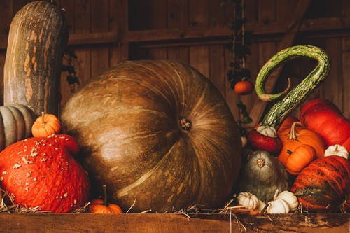 Thanksgiving 2019
Message from Archbishop Anne
Dear Friends in Christ,
This comes with my good wishes to you and yours for a very Happy Thanksgiving. Whether you will be celebrating it in the company of many or few, with rich foods or basic fare, I pray that gratitude will be at the heart of your gatherings. May your feasting begin in the Eucharist where we can really join with the Psalmist and say: “The Lord has done great things for us and our mouth was filled with laughter and our tongues with shouts of joy.” (Psalm 126) It is to this table that we bring our gifts of gratitude and unite them with the full gift of the life, death and resurrection of Jesus Christ and become one in him.
In the last edition of the Algoma Anglican I wrote about ‘The Counting House’ - the place we go to count our many blessings. In the midst of so much uncertainty and unrest in the world and closer to home, indeed in our very lives, there is much to be thankful for. Since I wrote that article I’ve been counting my own blessings and am grateful for the love and care of family, for the faithful witness of God’s people striving to share good news in hard times, for the privilege of serving as your archbishop, for the beauty of colour in nature as I travel from place to place, for the hospitality of friends and strangers, and for the sheer joy of being alive. I’m also grateful for the small pleasures of visits from children who live just around the corner or far away, for WhatsApp and Facetime that allows me to connect with family across oceans, for a cup of coffee alone in my study, for morning and evening prayer times that nourish my soul. Have you paid a visit to your counting house yet?

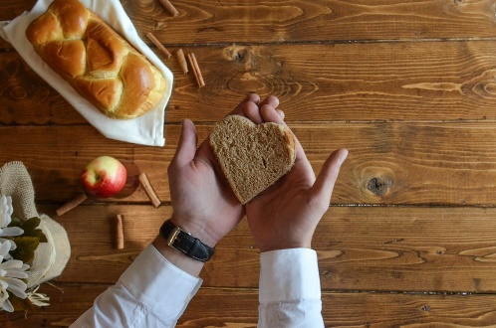
In this season of change, I want to let you know that there will be some changes coming in Algoma with respect to the Algoma Anglican newspaper that we look forward to receiving, along with the Anglican Journal every month. Newsy articles from around the diocese, teachings from Jay Koyle and Fr. Bob’s humour, along with history bytes, vital information about Synods and other diocesan gatherings, as well as photos galore have been published for decades all adding truth to Thomas King’s claim that stories is all that we are! (Massey Lectures 2003). Thank you to everyone for your faithful contributions over many years to our Diocesan newspaper!

Please join me in thanking the Rev. Peter Simmons for the amazing work he has done over the past thirteen years as the editor of the Algoma Anglican newspaper.
This week Peter let me know that he wishes to devote more time to St. Stephen’s Parish and will be resigning as our newspaper’s editor with immediate effect. Always passionate about ensuring that the stories of ministry in Algoma are shared, Peter has undertaken his work with singlehanded devotion and care. Peter tells me that it takes him the best part of two weeks to publish a newspaper like the Algoma Anglican, but that every moment he has given to this task has been a joy and not a tedious task. Thank you Peter!
Peter’s departure as the editor of the Algoma Anglican leaves a big gap - one which will not easily be filled. We need to take some time to consider what communication in the diocese will look like in the short and longer term. Until such time as we can find a new editor for The Algoma Anglican there will not be a paper version of Algoma’s news. We are committed to working on this because we realize that there are many people in Algoma who do not have the internet and who really enjoy receiving the news in paper form. I will send out my monthly letter in an electronic version, and if you have any news to share I ask you to forward them to Liz by the 1st of the month. Because of budget concerns we had already decided to reduce the number of editions of the Algoma Anglican from ten to five in 2020.
One of the problems that we have been facing with respect to the Algoma Anglican is the lack of contributions from parishes and deaneries which makes it difficult to publish a fulsome newspaper. As you know, it takes ‘two to story’ – there must be ‘tellers’ and ‘hearers’ wanting to share the good news of how God is at work in their communities. The truth is that important stories about our faith aren’t just for being nostalgic and reflecting on the ‘good old days’, they are actually about ‘re-membering’ about putting us back together as people and communities in renewing and life enhancing ways. As we read and hear the important stories from across Algoma we see how interconnected we all are, in spite of our vast geography that often conspires to keep us apart.
As you know the nature of communication has changed dramatically globally, with electronic delivery of news becoming the norm. It wasn’t that long ago that we picked up the daily news in print form and now we pick it up on our iPhones as it is happening. Unlike other dioceses we do not have the budget for a full time communications officer and are dependent upon our already busy Synod office staff to help with this. We are delighted with our new website especially as it has the capacity to generate the e-news updates straight from it instead of going through a third party. Thanks to Guy Snell for taking care of this for years. I am grateful to Liz Hamel for the tremendous job she does in posting those updates in a timely fashion, and likewise to Jay Koyle for being the Administrator of our Facebook account (Diocese of Algoma: Shaped by a Living Hope).
Algoma needs a new communication strategy. In the coming months we will be forming a committee to look at how we might become even more effective in our communications in and around the diocese. Please be patient as we become a work in progress and know that we will find a way to get news to you.
With gratitude for your sharing in the life and witness of the gospel in Algoma,

+Anne

